CASE-STUDY (NUMBER - 10) – SOLUTION SUBMISSION

ON

AZURE ANALYTICS

BY

NAME –SUPRIYA BHARATHA ROLL NUMBER DXCAB1211

BATCH:DXC-262-ANALYTICS-B12-AZURE COMPANY – DXC TECHNOLOGY

TRAINING UNDER – MANIPAL PRO LEARN TRAINER NAME – MR. AJAY KUMAR DATE OF SUBMISSION – 15th JUNE 2022 TOTAL NUMBER OF QUESTIONS: 06

EMPLOYEE DOMAIN - AZURE ANALYTICS

* THE QUESTIONS:

1.Using archive1.zip file - please ingest data into databricks DBFS path & query the data, redesign columns accordingly using dafarame commands - display with notebooks accordingly

2.Using archive2.zip file - please ingest data into databricks DBFS path & query the data redesign columns accordingly using dafarame commands - display with notebooks accordingly

3.Using archive3.zip file - please ingest data into databricks DBFS path & query the data redesign columns accordingly using dafarame commands - display with notebooks accordingly

4.Using archive4.zip file - please ingest data into databricks DBFS path & query the data redesign columns accordingly using dafarame commands - display with notebooks accordingly

5.Using archive5.zip file - please ingest data into databricks DBFS path & query the data redesign columns accordingly using dafarame commands - display with notebooks accordingly

6.Using archive6.zip file - please ingest data into databricks DBFS path & query the data redesign columns accordingly using dafarame commands - display with notebooks accordingly

1.Using archive1.zip file - please ingest data into databricks DBFS path & query the data, redesign columns accordingly using dafarame commands - display with notebooks accordingly

SOLUTION

* Open azure portal and search for databricks

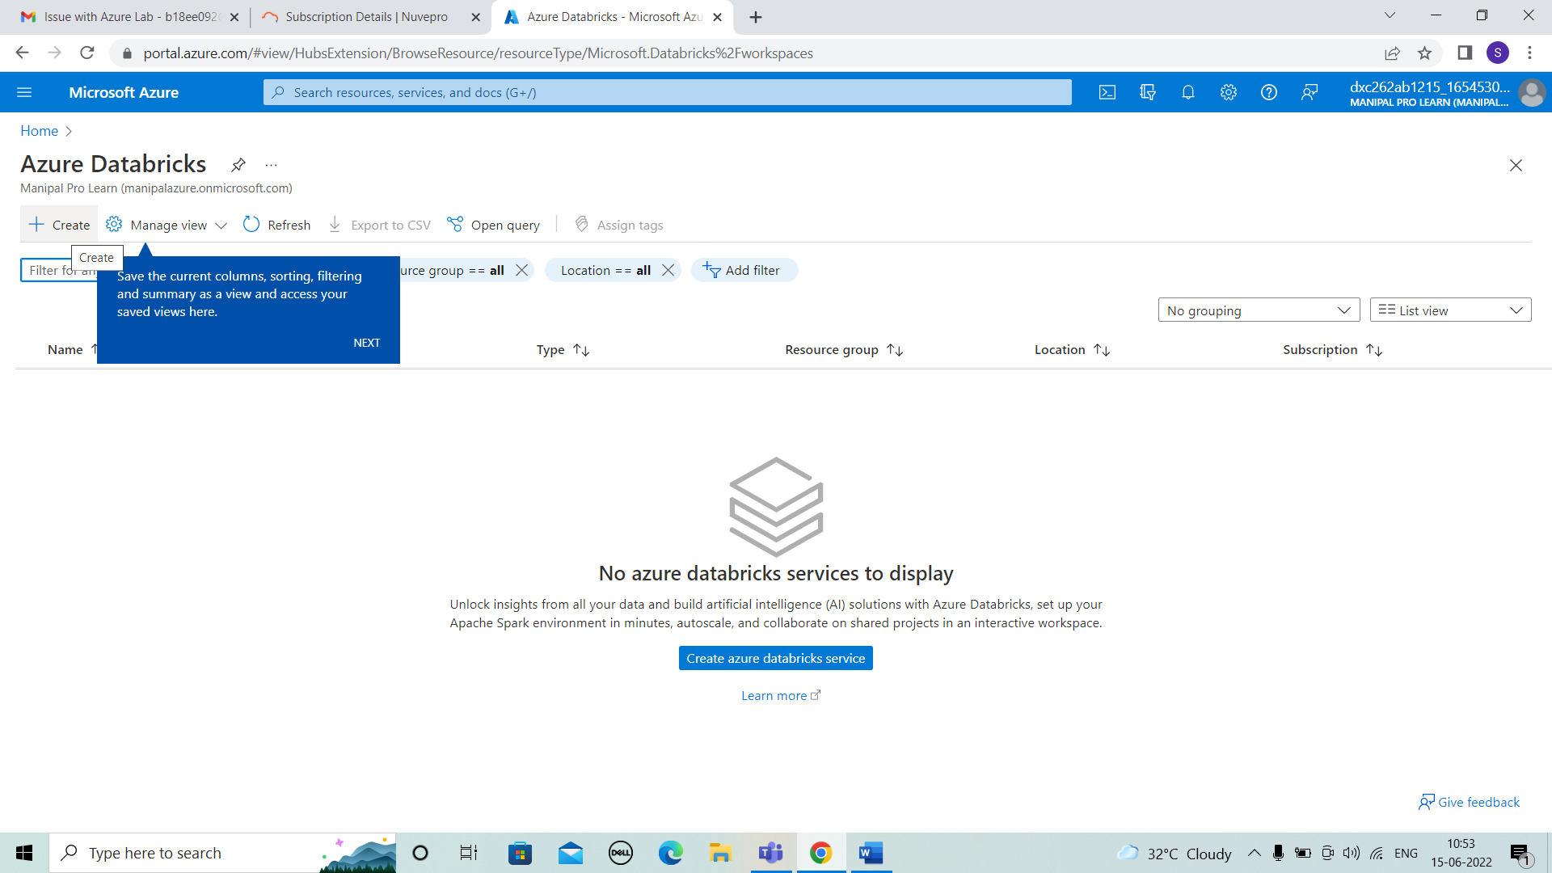

* Enter the details of Resource group, Workspace name, Pricing tier and click on review+create.

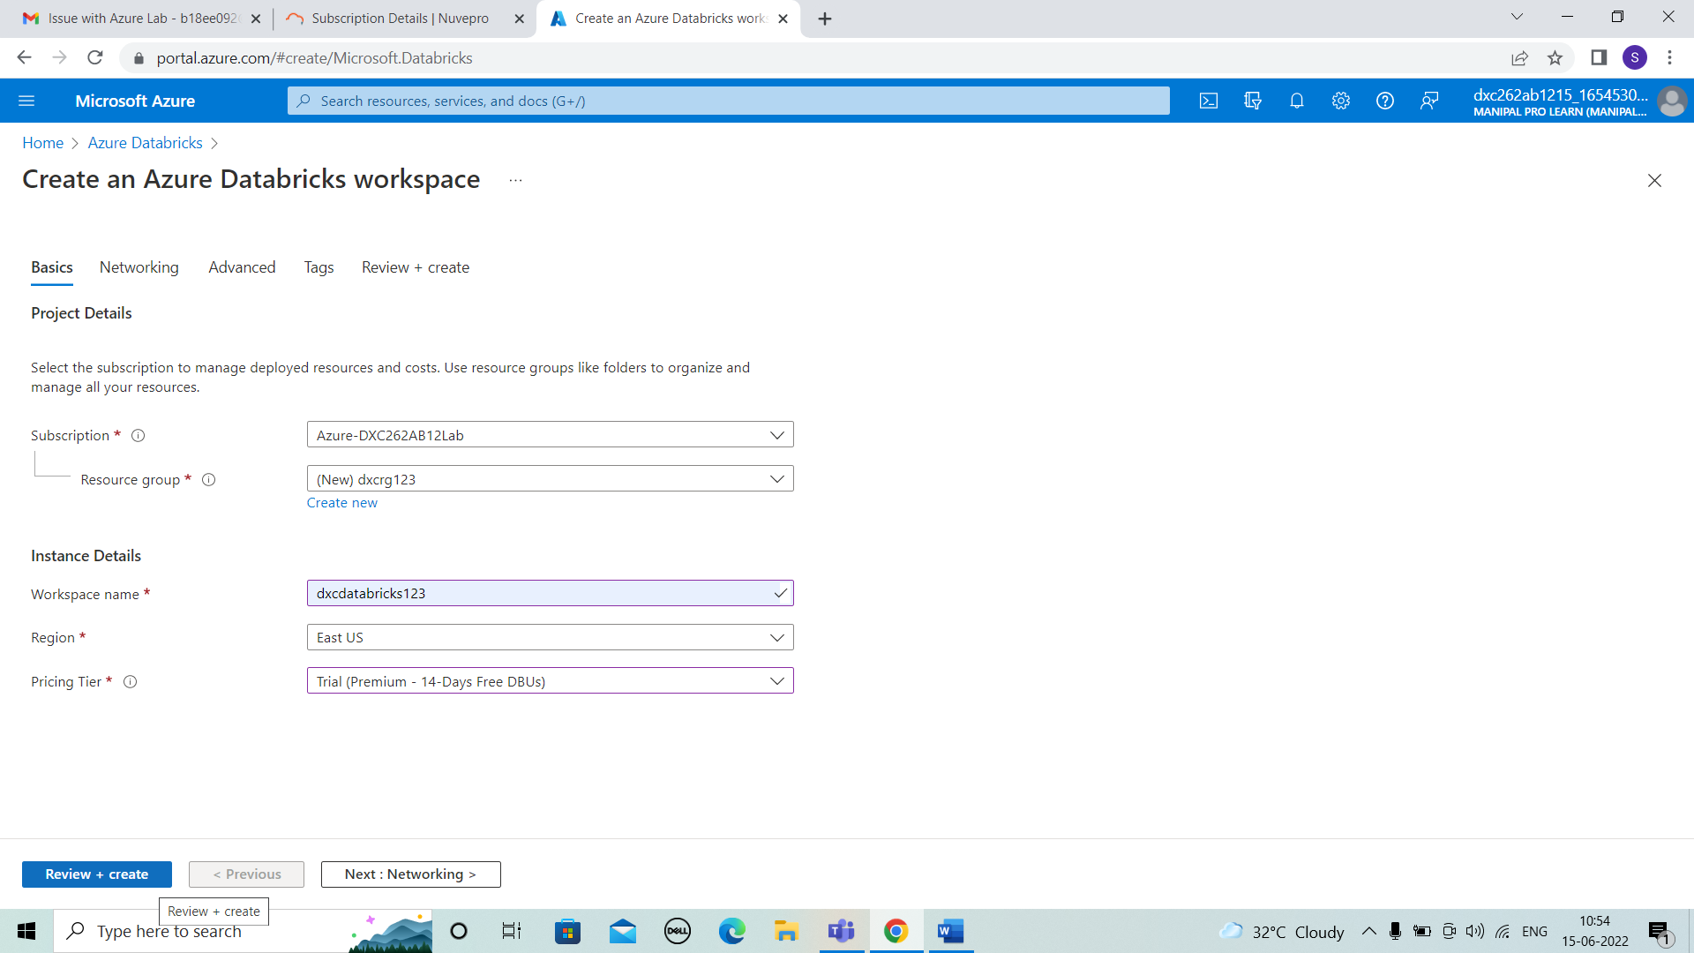

* After that it is validated and then check the details and click on create.

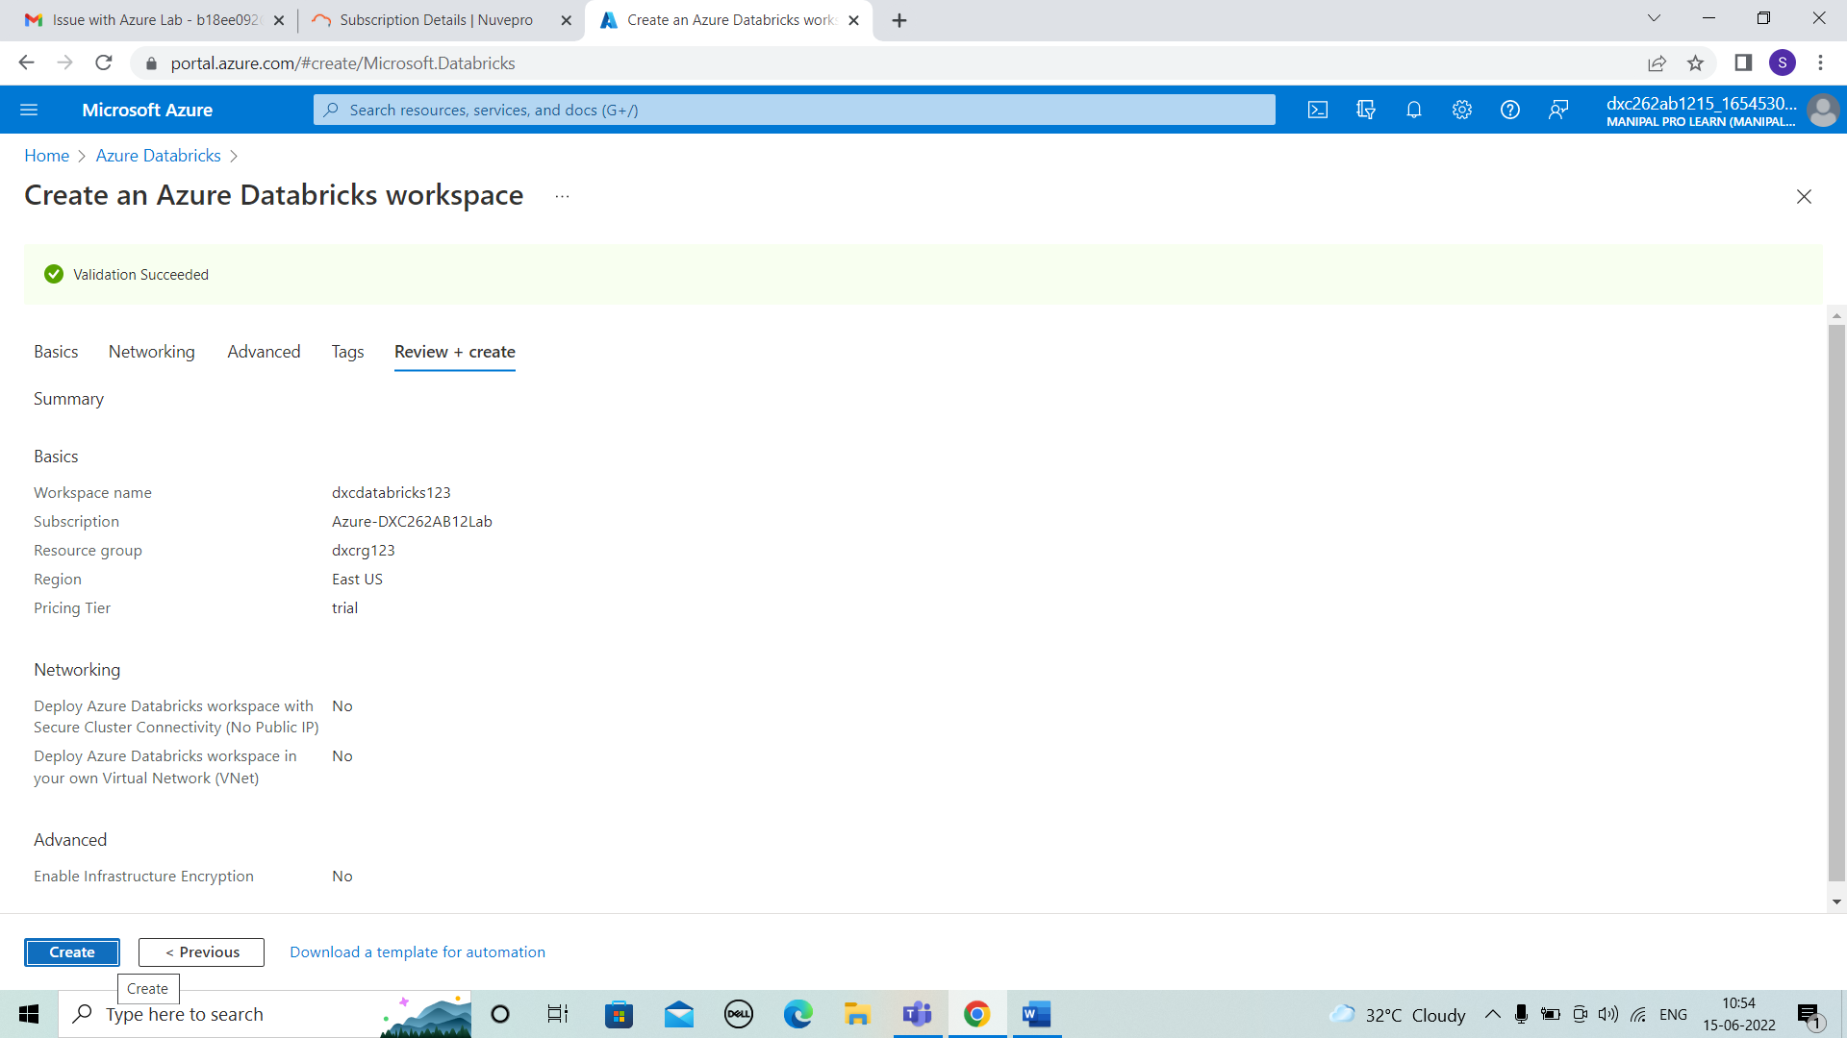

* Then deployment is completed. Then go to resource

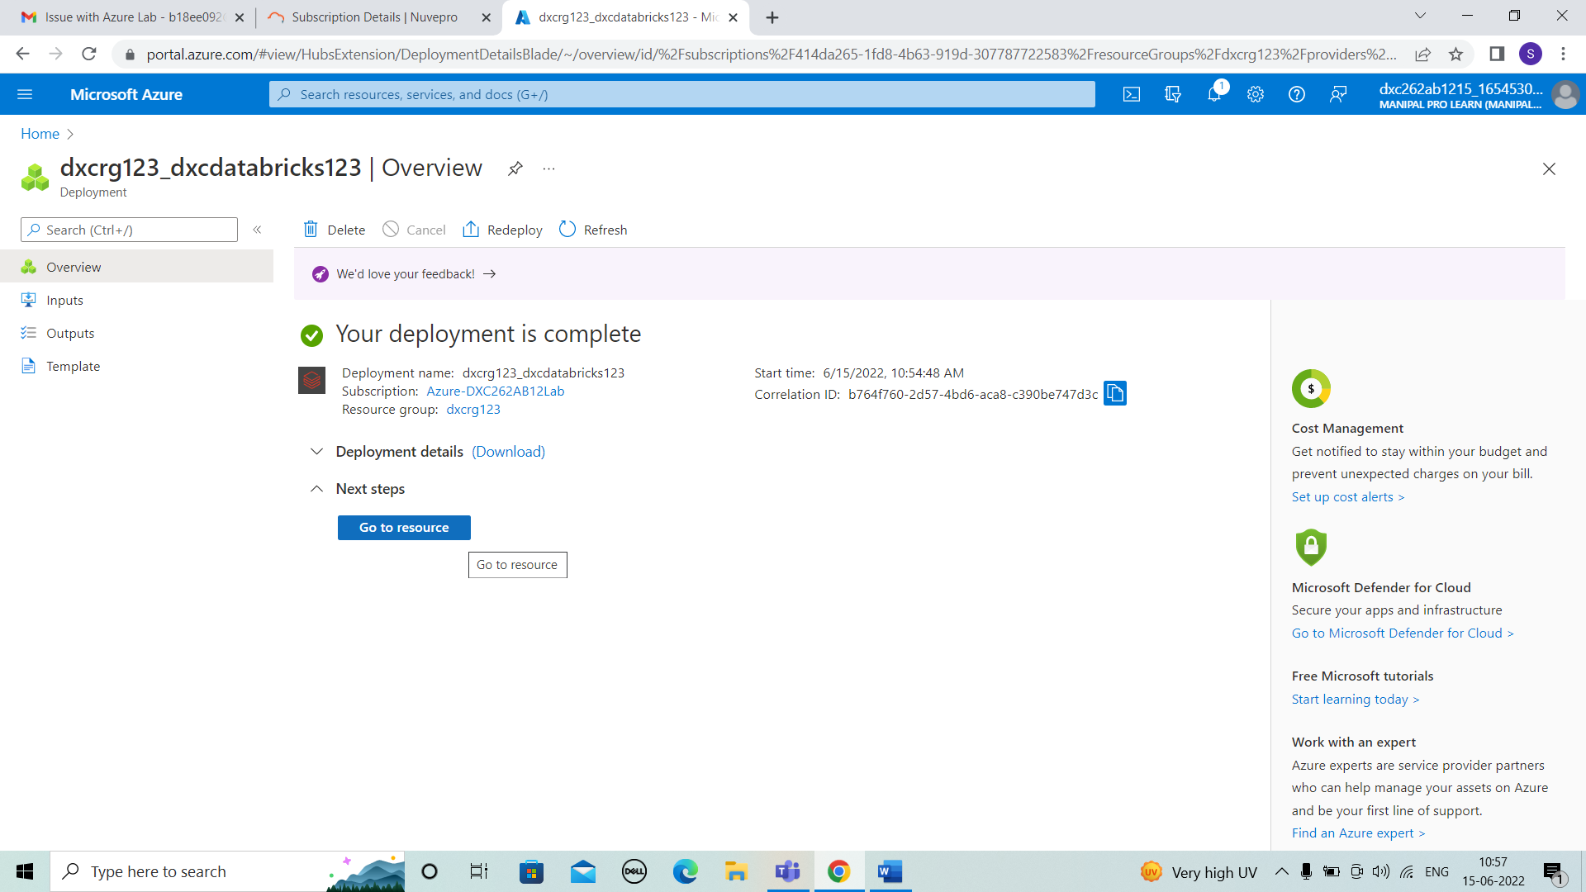

* We can see the overview of databricks and then click on launch workspace.

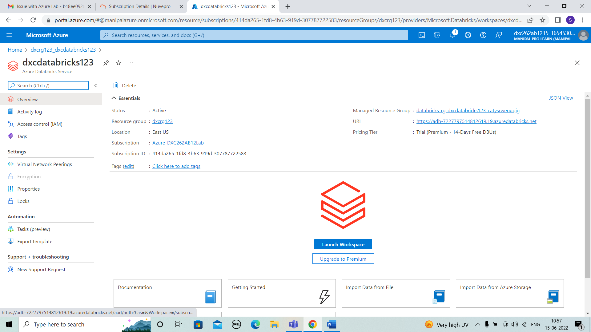

* For creating new cluster go to create > cluster ,then enter the cluster name and cluster mode,and terminate time.

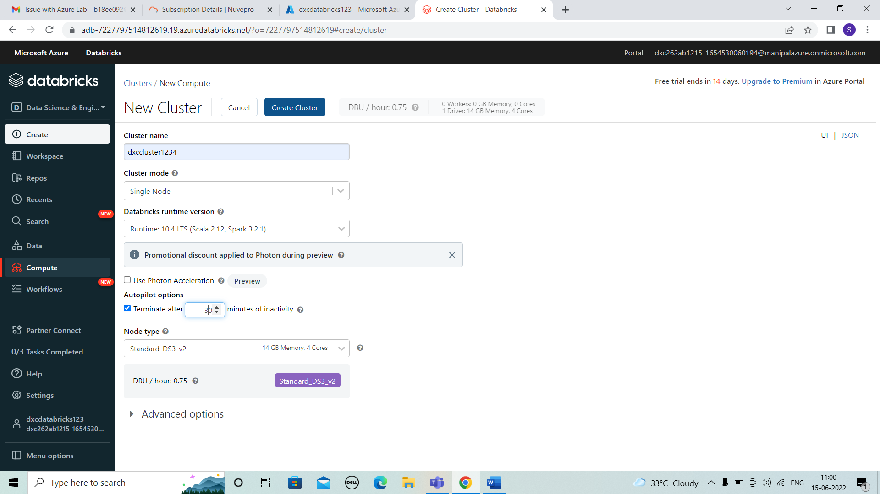

* Then cluster creation is under progess.

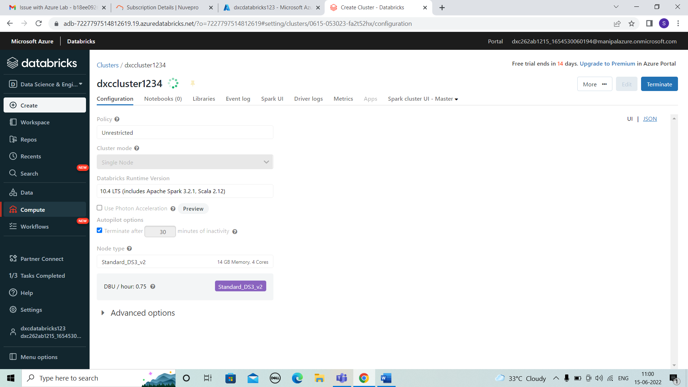

* After sometime the cluster is created.

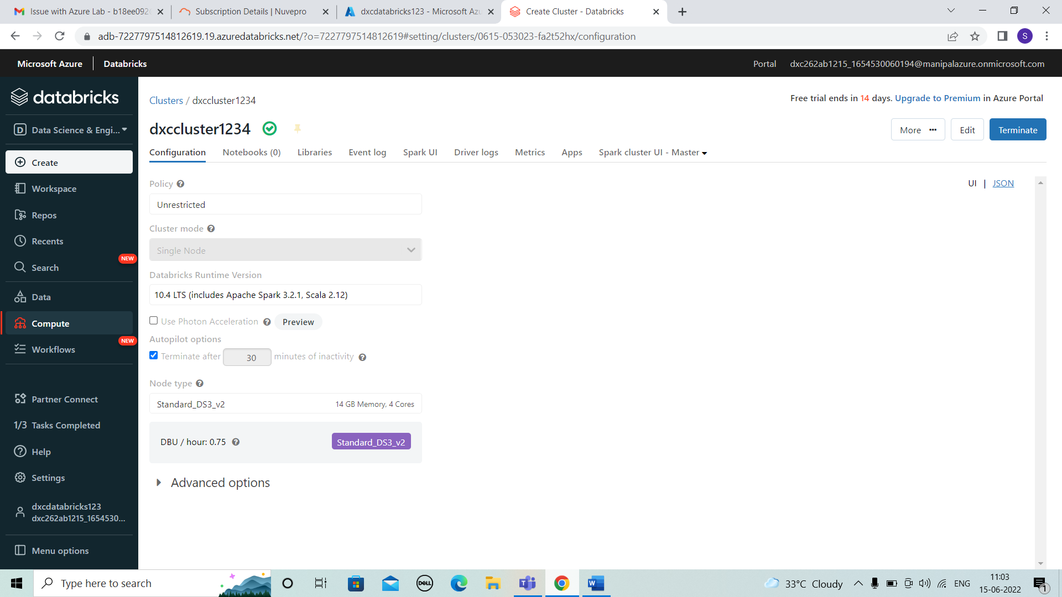

* Create a folder to note the notebooks.

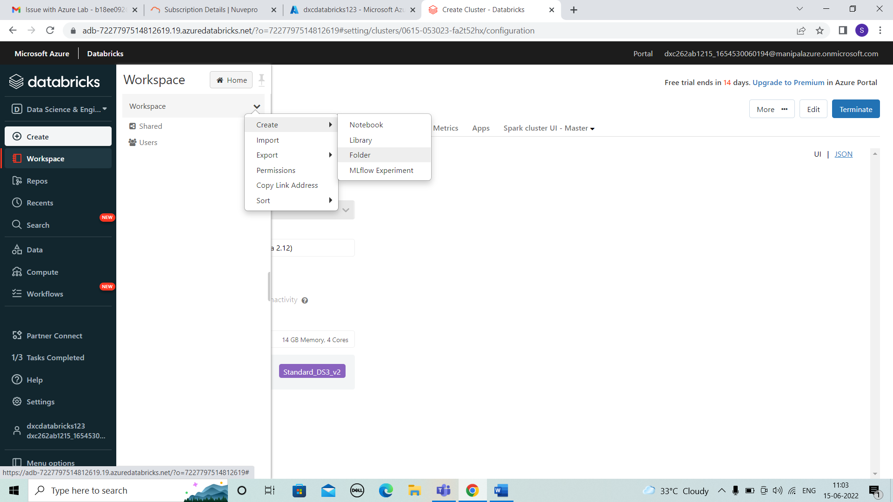

* Enter the name of folder that we needed.

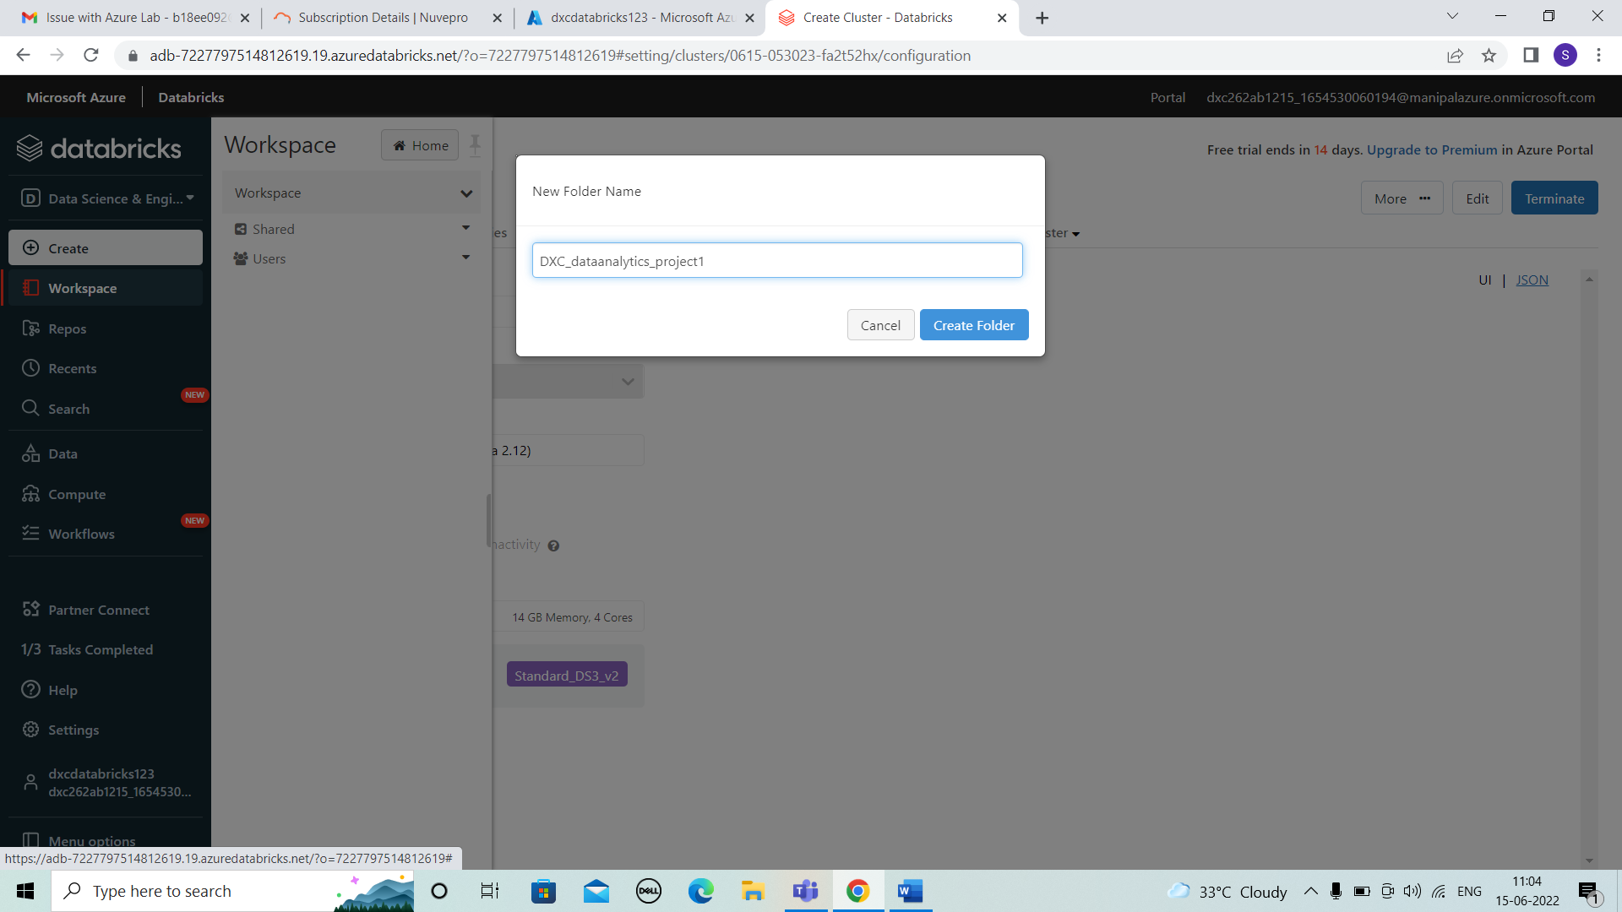

* After creating the folder , open it and then create > notebook. And enter the details.

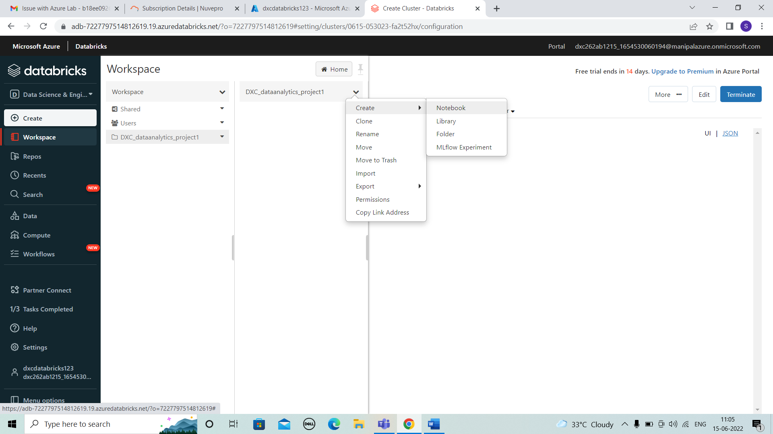

* Enter the code or logic in notebook .

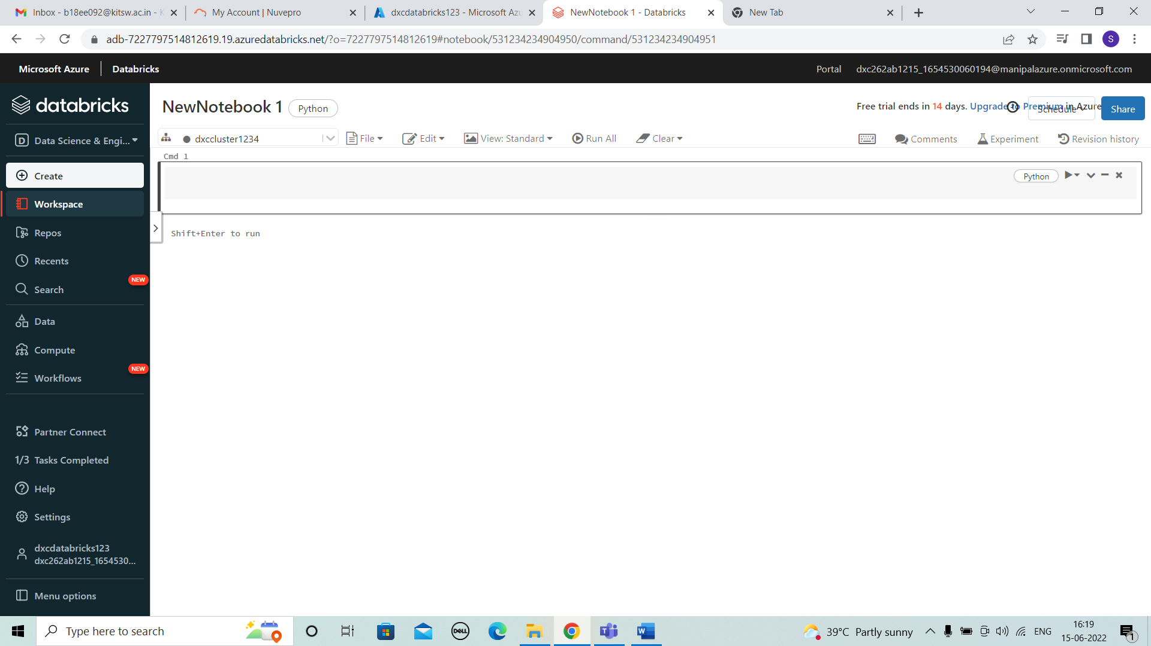

* Create a table by uploading a file and then go to > DBFS to view it. And enter the code in notebook shown below to access the data uploaded .

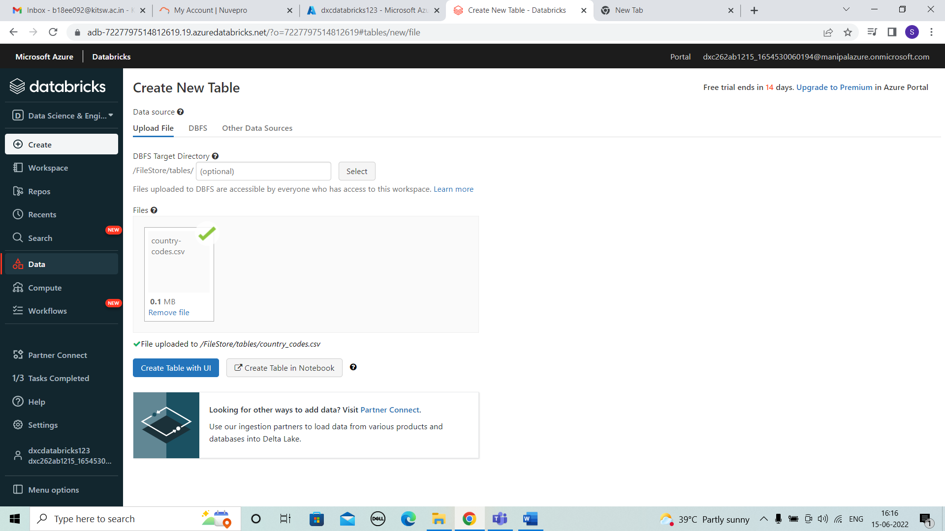

* #Ingest country-codes.csv file

#read the country-codes.csv

from pyspark.sql.types import StructType, StructField, IntegerType, StringType, DateType

* country-codes_schema=StructType(fields=[StructField("FIFA",StringType(),False),

StructField("Dial", IntegerType(),True),

StructField("ISO3166-1-Alpha-3", StringType(),True),

StructField("MARC", StringType(),True),

StructField("Expense", StringType(),True),

StructField("is_independent", StringType(),True),

StructField("ISO3166-1-numeric", IntegerType(),True),

StructField("GAUL", IntegerType(),True),

StructField("FIPS", StringType(),True),

StructField("WMO", StringType(),True),

StructField("ISO3166-1-Alpha-2", StringType(),True),

StructField("ITU", StringType(),True),

StructField("IOC", StringType(),True),

StructField("DS", StringType(),True),

StructField("UNTERM Spanish Formal", StringType(),True),

StructField("Global Code", StringType(),True),

StructField("Intermediate Region Code", IntegerType(),True),

StructField("official_name_fr", StringType(),True),

StructField("UNTERM French Short", StringType(),True),

StructField("ISO4217-currency_name", StringType(),True),

StructField("Developed / Developing Countries ", StringType(),True),

StructField("UNTERM Russian Formal", StringType(),True),

StructField("UNTERM English Short", StringType(),True),

StructField("ISO4217-currency_alphabetic_code ", StringType(),True),

StructField("Small Island Developing States (SIDS)", StringType(),True),

StructField("UNTERM Spanish Short", StringType(),True),

StructField("ISO4217-currency_numeric_code", IntegerType(),True),

StructField("UNTERM Chinese Formal", StringType(),True),

StructField("UNTERM French Formal", StringType(),True),

StructField("UNTERM Russian Short", StringType(),True),

StructField("M49", IntegerType(),True),

StructField("Sub-region Code", IntegerType(),True),

StructField("Region Code", IntegerType(),True),

StructField("official_name_ar", StringType(),True),

StructField("ISO4217-currency_minor_unit", IntegerType(),True),

StructField("UNTERM Arabic Formal", StringType(),True),

StructField("UNTERM Chinese Short ", StringType(),True),

StructField("Land Locked Developing Countries (LLDC)", StringType(),True),

StructField("Intermediate Region Name", StringType(),True),

StructField("official_name_es", StringType(),True),

StructField("UNTERM English Formal", StringType(),True),

StructField("official_name_cn", StringType(),True),

StructField("official_name_en", StringType(),True),

StructField("ISO4217-currency_country_name", StringType(),True),

StructField("Least Developed Countries (LDC)", StringType(),True),

StructField("Region Name", StringType(),True),

StructField("UNTERM Arabic Short", StringType(),True),

StructField("Sub-region Name", StringType(),True),

StructField("official_name_ru", StringType(),True),

StructField("Global Name", StringType(),True),

StructField("Capital", StringType(),True),

StructField("Continent", StringType(),True),

StructField("TLD", StringType(),True),

StructField("Languages", StringType(),True),

StructField("Geoname ID", IntegerType(),True),

StructField("CLDR display name", StringType(),True),

StructField("EDGAR", IntegerType(),True)

])

* country-codes_df= spark.read\

.option("header", True)\

.schema(country-codes_schema)\

.csv("/FileStore/tables/country-codes.csv")

* #add ingestion date

from pyspark.sql.functions import current_timestamp, to_timestamp, concat, col, lit

* country-codes_with_timestamp_df=country-codes_df.withColumn("ingestion_date",current_timestamp())
* #select only column that are required &rename as required

country-codes_selected_df=country-codes_with_timestamp_df.select(col('FIFA'),col('Dial'),col('ISO3166-1-Alpha-3').alias('ISO3166.1-Alpha3'),col('MARC') ,col('is_independent').alias('is independent'),col('ISO3166-1-numeric') ,col('GAUL') ,col('FIPS') ,col('WMO') ,col('ISO3166-1-Alpha-2') ,col('ITU') ,col('IOC’) , col('DS') ,col('UNTERM Spanish Formal').alias('UNTERM_Spanish_Formal') ,col('Global Code') ,col('Intermediate Region Code') ,col('official_name_fr').alias('official name for') ,col('UNTERM French Short') ,col('ISO4217-currency_name').alias('ISO4217 currencyname') ,col('Developed / Developing Countries') ,col('UNTERM Russian Formal') ,col('UNTERM English Short') ,col('ISO4217-currency_alphabetic_code') ,col('Small Island Developing States (SIDS)') ,col('UNTERM Spanish Short') ,col('ISO4217-currency_numeric_code') ,col('UNTERM Chinese Formal') ,col('UNTERM French Formal') ,col('UNTERM Russian Short') ,col('M49') ,col('Sub-region Code'),col('Region Code') ,col('official_name_ar').alias('official name are'),col('ISO4217-currency_minor_unit'),col('UNTERM Arabic Formal'),col('UNTERM Chinese Short') ,col('Land Locked Developing Countries (LLDC)') ,col('Intermediate Region Name') ,col('official_name_es'),col('UNTERM English Formal') ,col('official_name_cn').alias('official name cn') ,col('official_name_en').alias('official name en') ,col('ISO4217-currency_country_name') ,col('Least Developed Countries (LDC)') ,col('Region Name') ,col('UNTERM Arabic Short') ,col('Sub-region Name') ,col('official_name_ru').alias('official name ru') ,col('Global Name'),col('Capital'),col('Continent') ,col('TLD') ,col('Languages'), col('Geoname ID').alias('Geoname_ID') ,col('CLDR display name') ,col('EDGAR')

* #write the output to processed container in parquet format

country-codes_selected_df.write.mode('overwrite').parquet('/mnt/formulaIdl/processed/races')

* display(country-codes_selected_df)
* country-codes_selected_df.show()

2.Using archive2.zip file - please ingest data into data bricks DBFS path & query the data redesign columns accordingly using data frame commands - display with notebooks accordingly

SOLUTION

* Open to create table and upload the file . Here , all the files the are uploaded and create separate notebooks for each to perform.

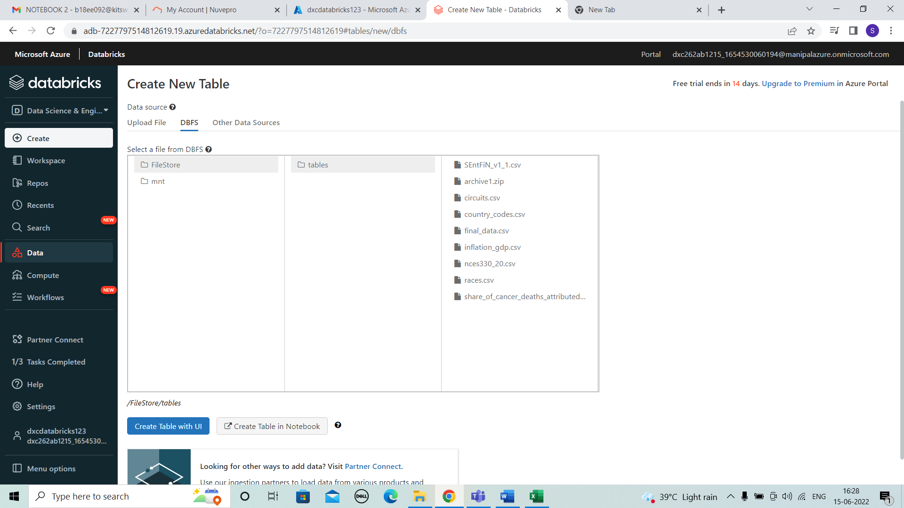

* Open notebook and enter the code below to ingest and read file.

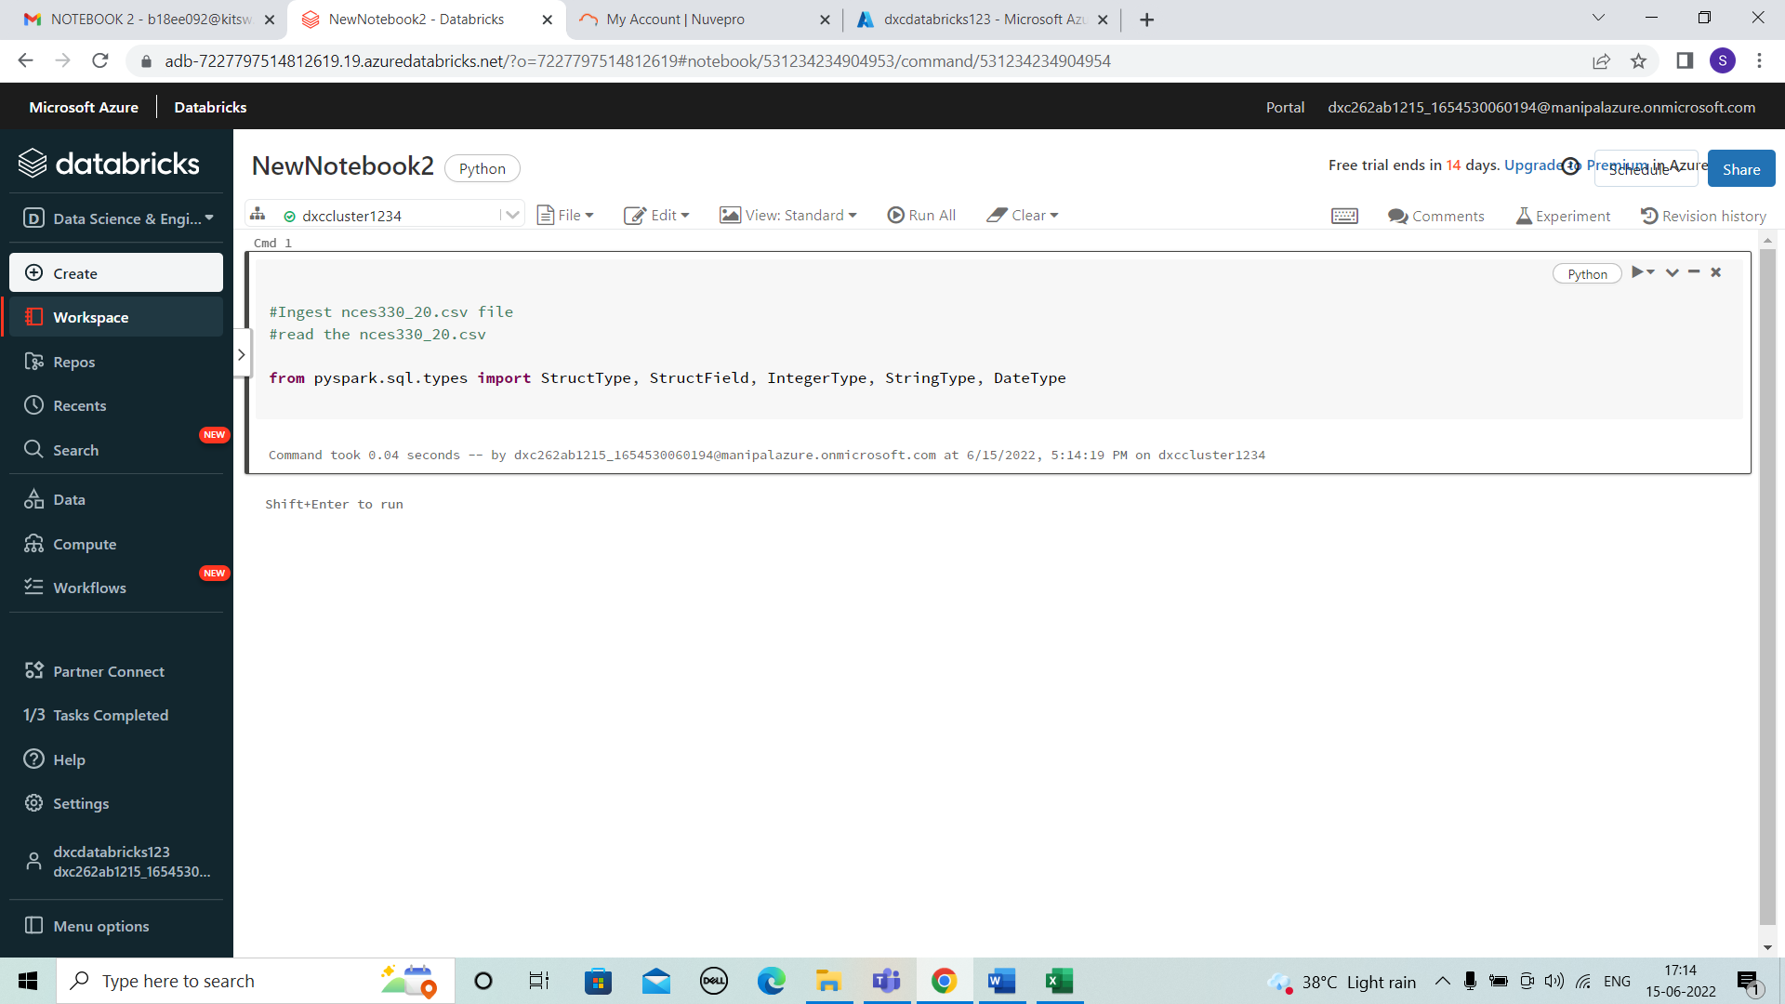

* Enter the details of all the columns that are considered in the file. And the type of data used.

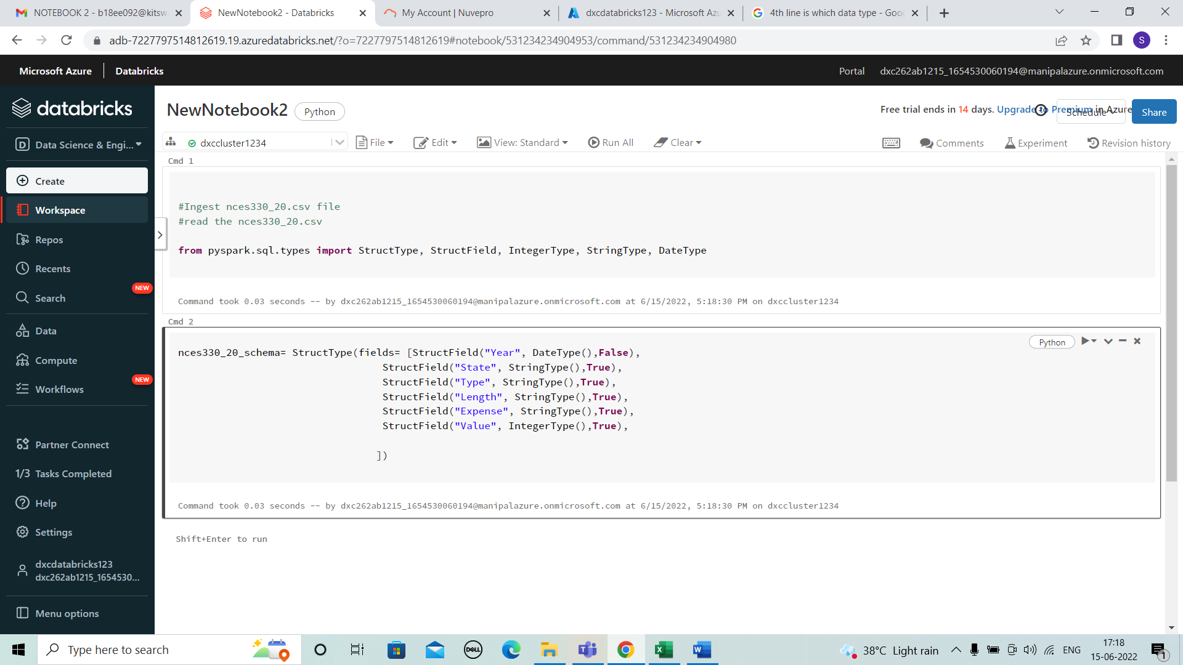

* Here the below code shows the data used.

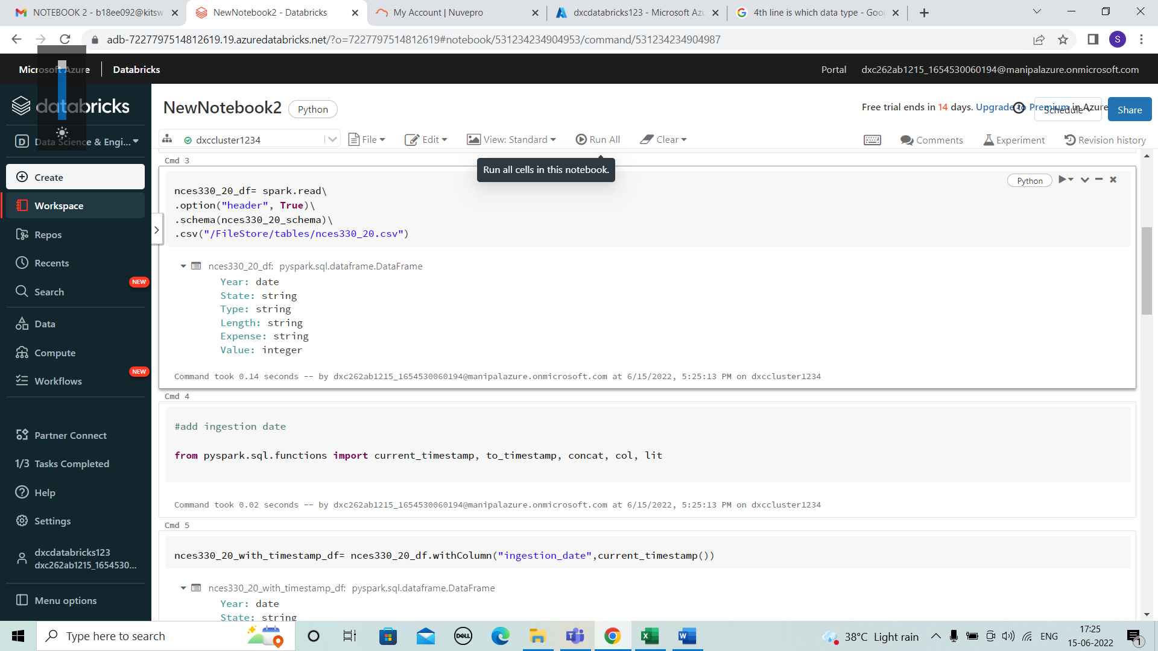

* We add the ingestion date for the data. Here, We need to select the column names which should be renamed and enter the names to be replaced.

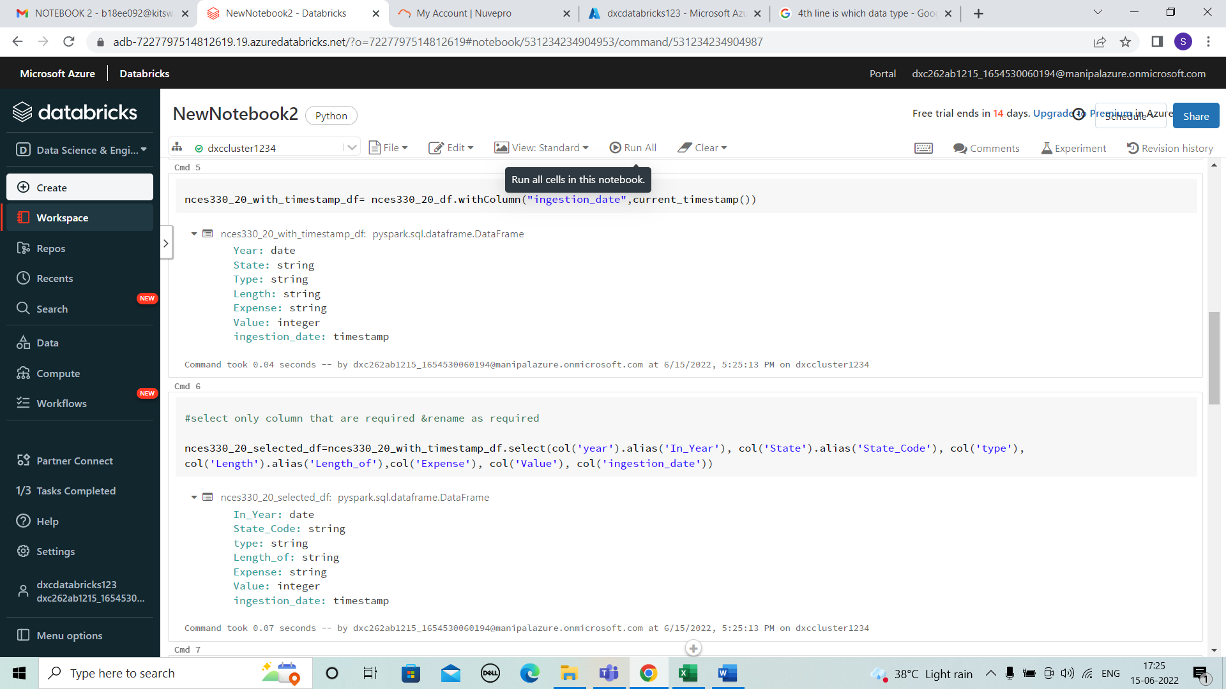

* Next the output to processed container in parquet format. And view the spark job.

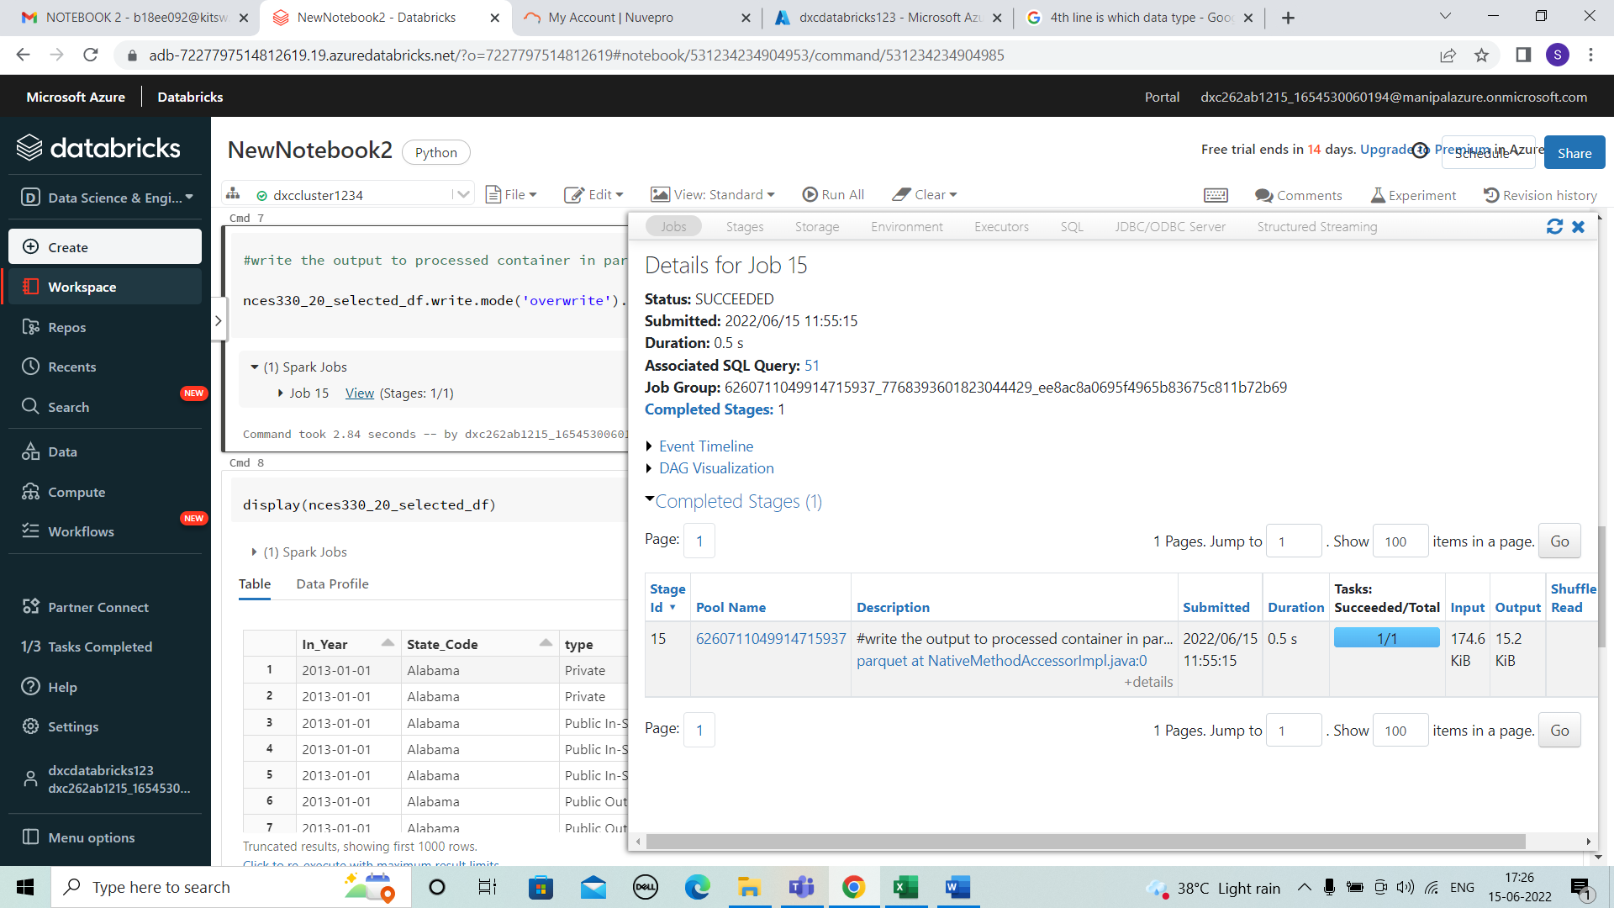

* Enter the below code to view the final table or the data modifies in the notebook.

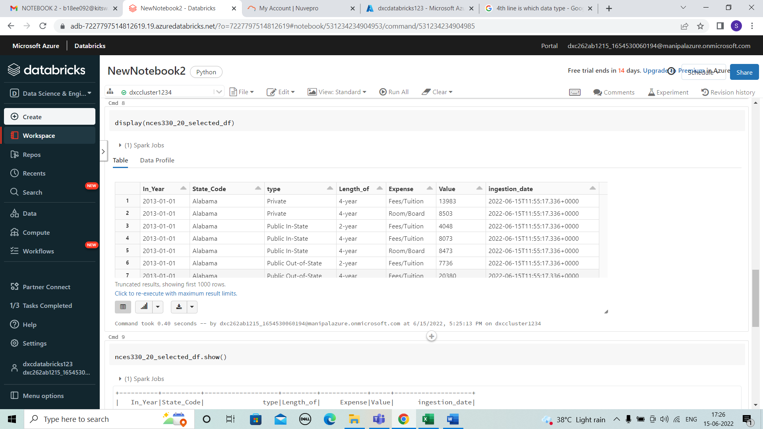

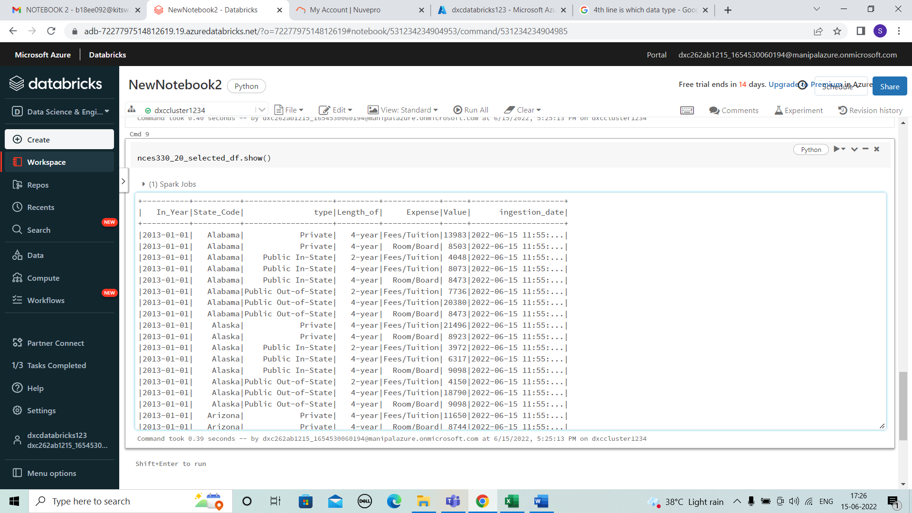

3.Using archive3.zip file - please ingest data into databricks DBFS path & query the data redesign columns accordingly using dafarame commands - display with notebooks accordingly

SOLUTION

* Open to create table and upload the file . Here ,final_data.csv is uploaded. Open notebook and enter the code below to ingest and read file. Enter the details of all the columns that are considered in the file. And the type of data used.

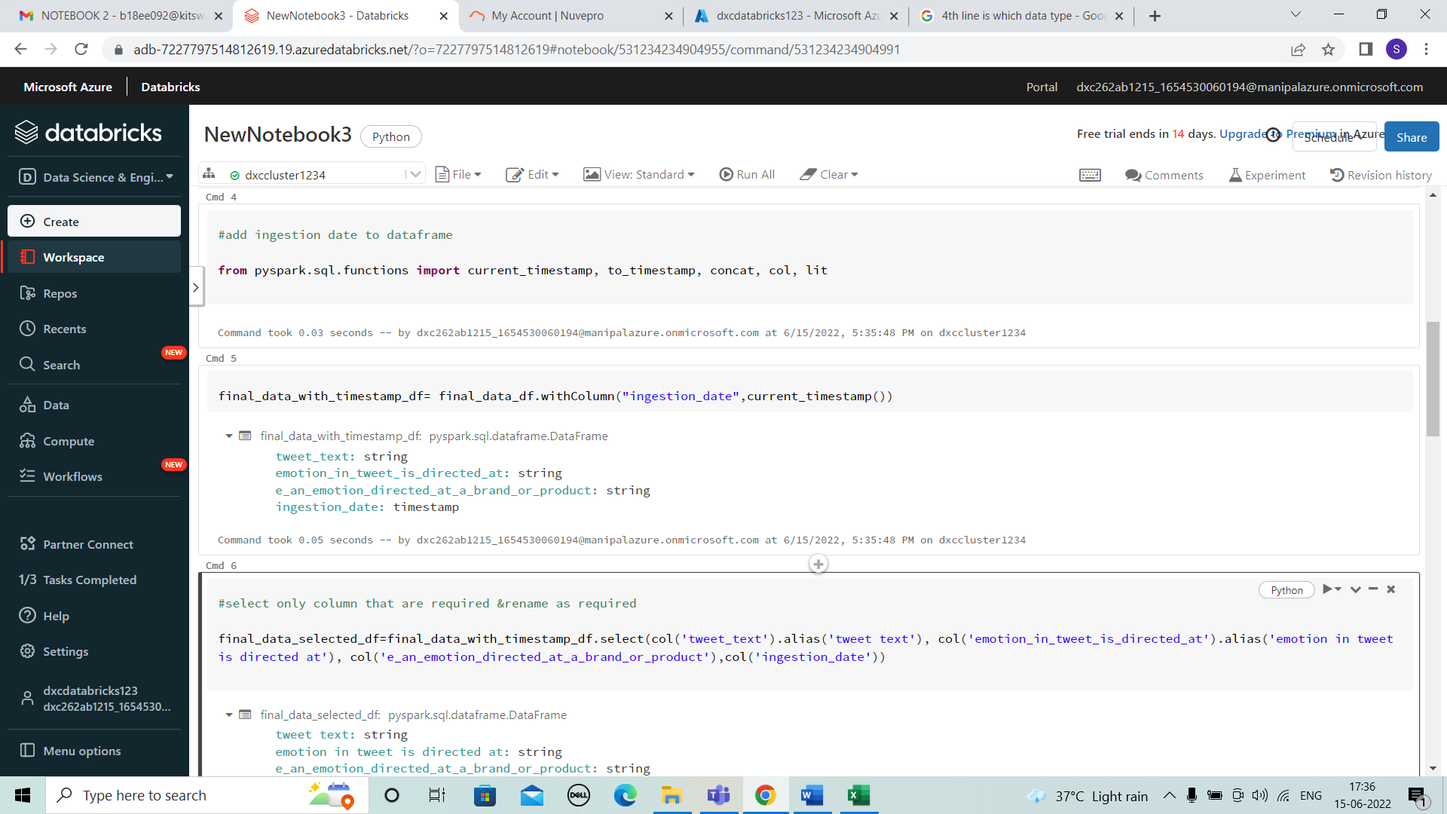

* Here the below code shows the data used. We add the ingestion date for the data. Here, We need to select the column names which should be renamed and enter the names to be replaced.

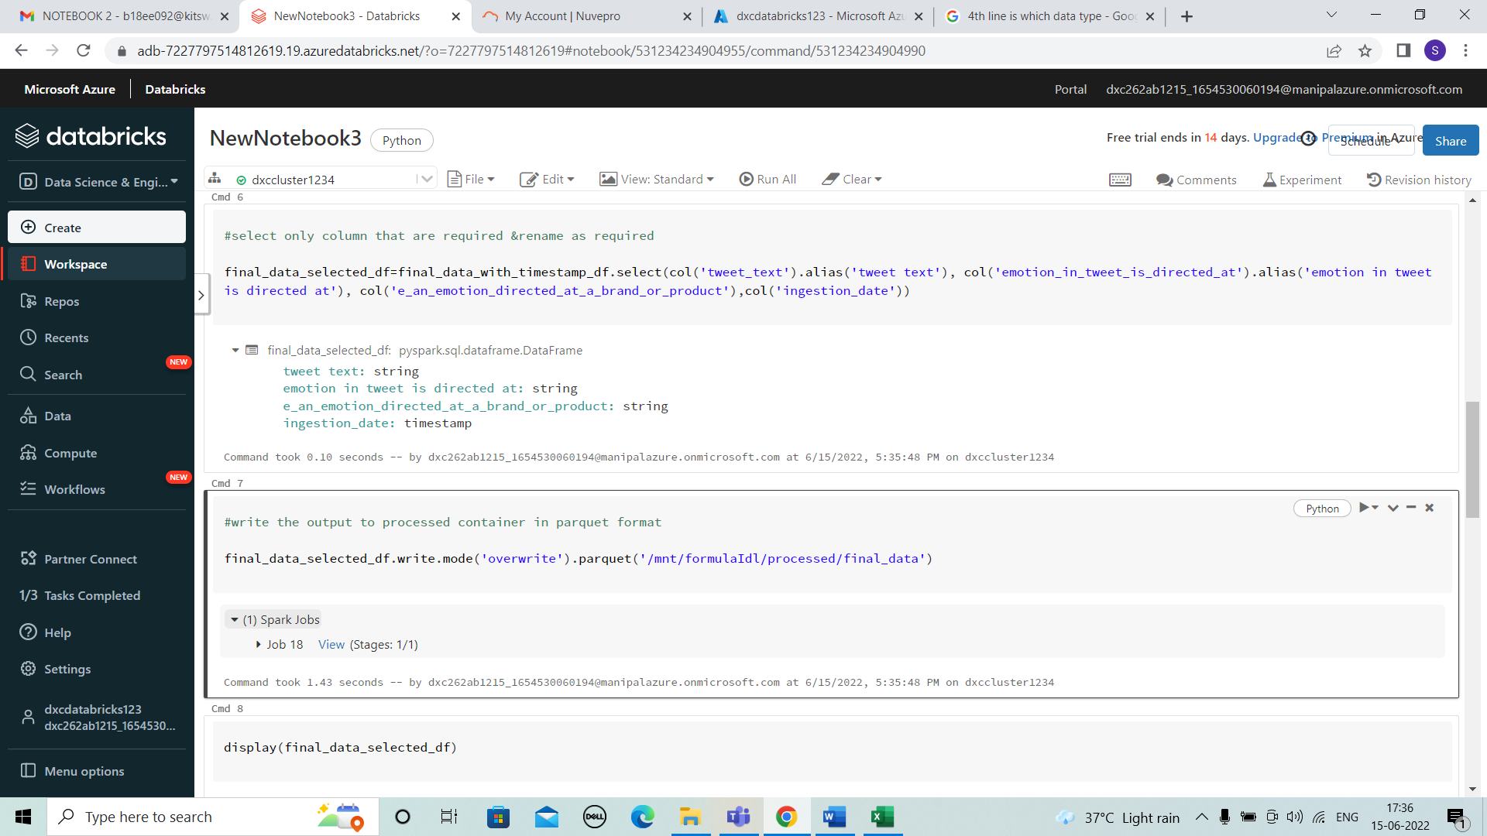

* Next the output to processed container in parquet format. And view the spark job.

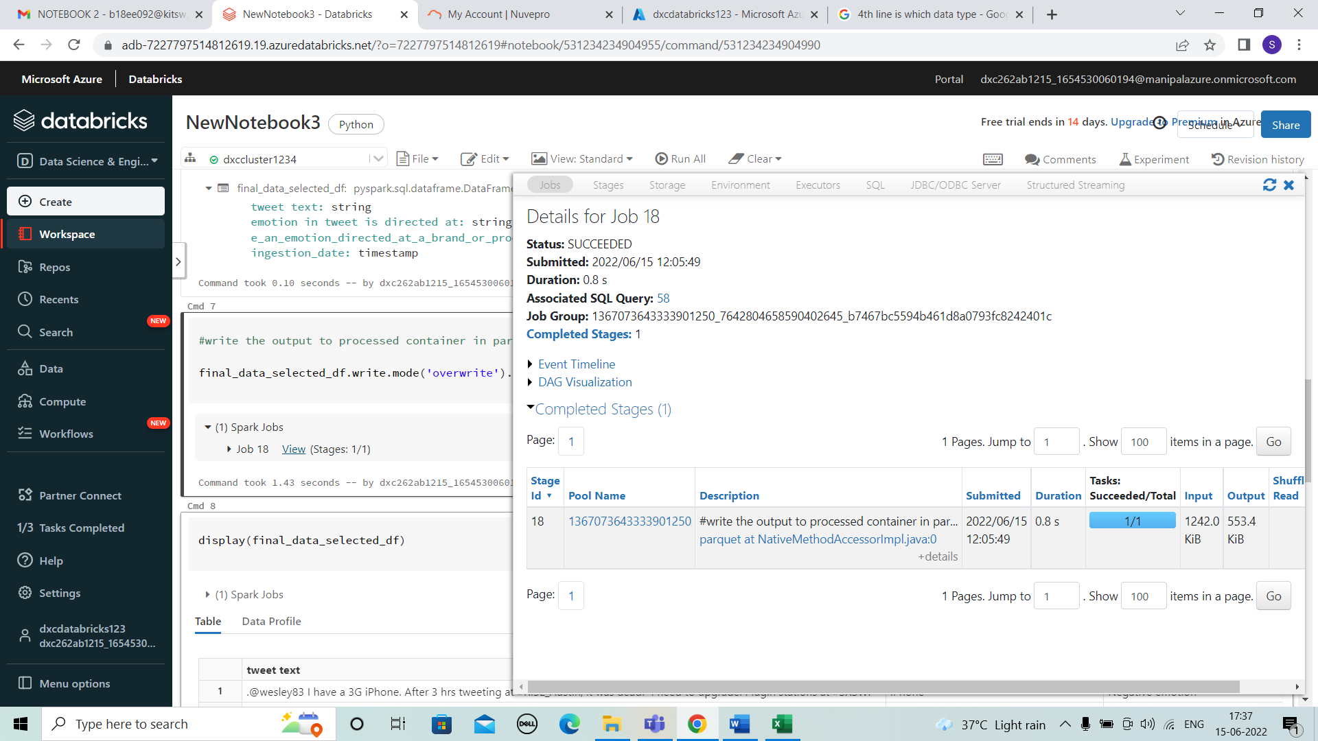

* Enter the below code to view the final table or the data modifies in the notebook.

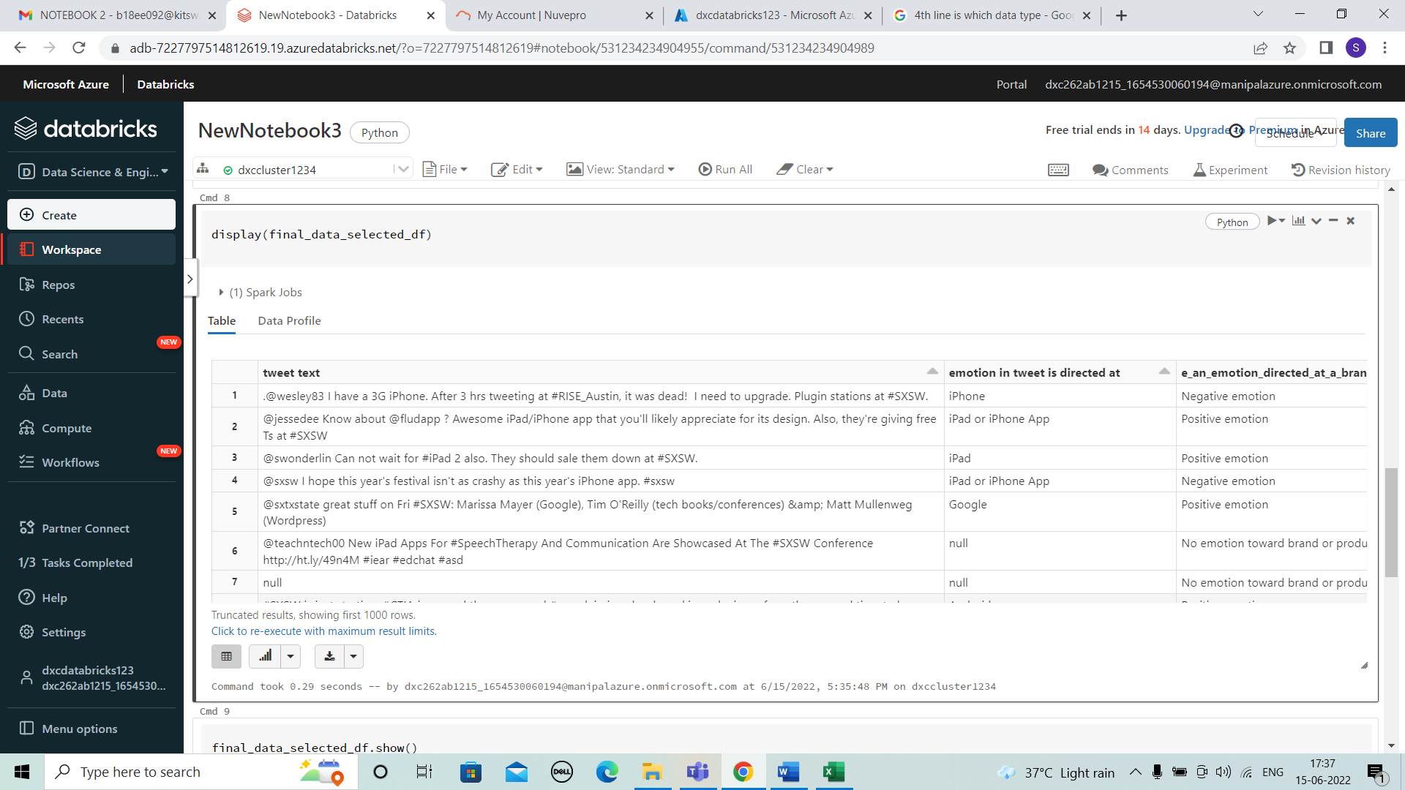

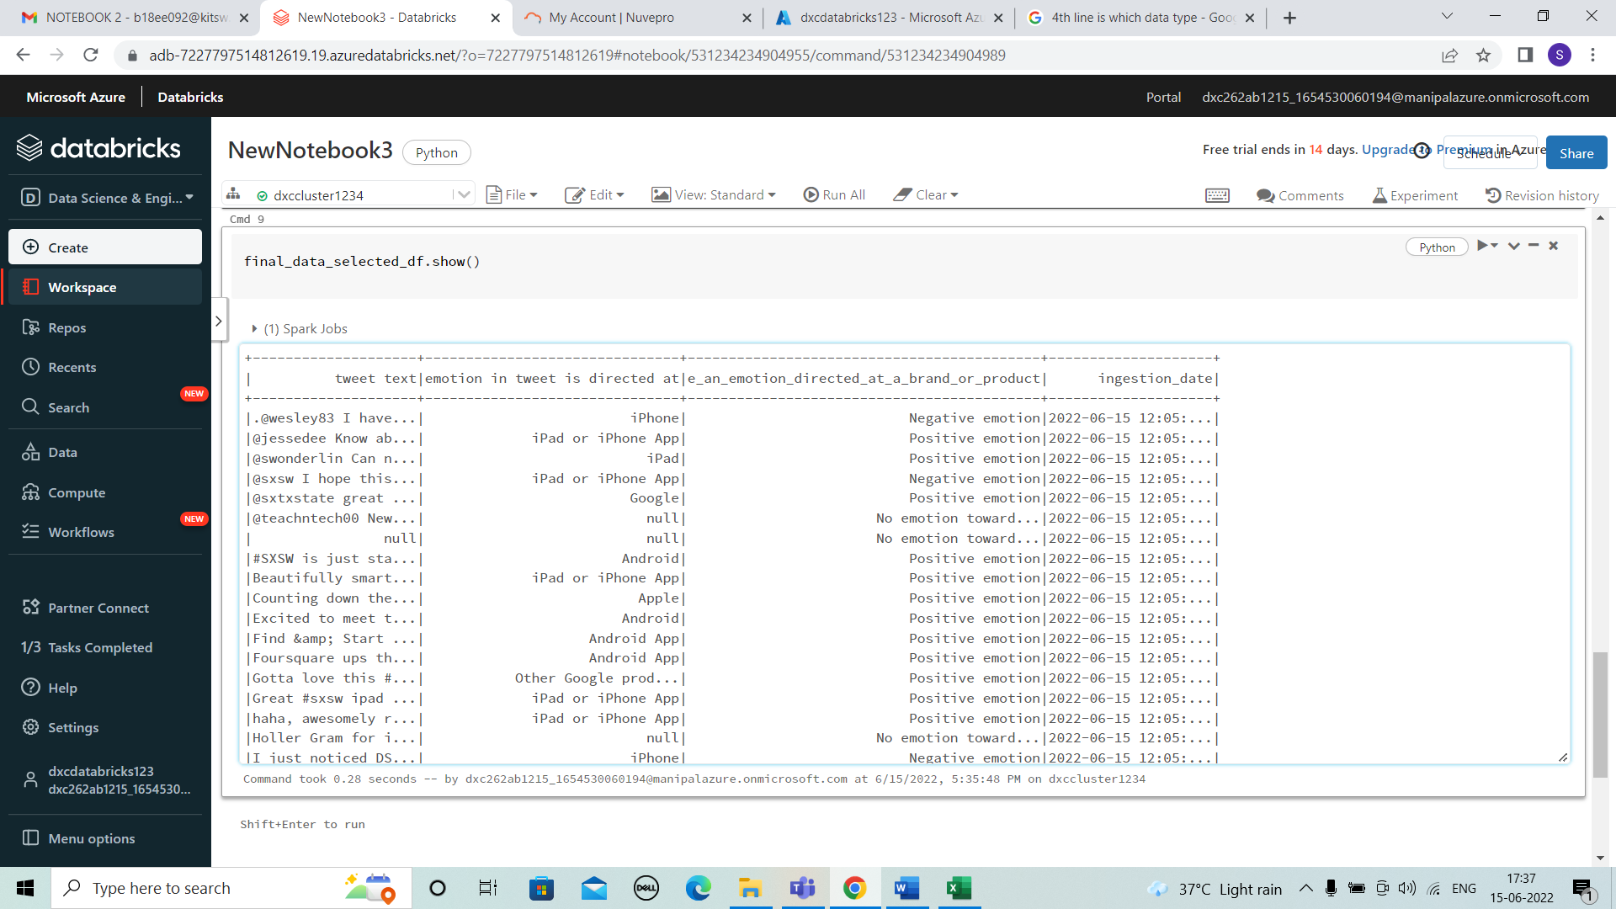

4.Using archive4.zip file - please ingest data into databricks DBFS path & query the data redesign columns accordingly using dafarame commands - display with notebooks accordingly

SOLUTION

* from pyspark.sql.types import StructType, StructField, IntegerType, StringType, DateType, FloatType
* SEntFiN_v_schema = StructType(fields= [StructField(&quot;S No&quot;,IntegerType(),False),

StructField(&quot;Title&quot;,StringType(),True),

StructField(&quot;Decisions&quot;,StringType(),True),

StructField(&quot;Words&quot;,IntegerType(),True),

StructField(&quot;date&quot;, DateType(),True),

StructField(&quot;time&quot;, StringType(),True),

StructField(&quot;url&quot;, StringType(),True),

])

* SEntFiN_v_df= spark.read\

.option(&quot;header&quot;, True)\

.schema(SEntFiN_v_schema)\

.csv(&quot;/FileStore/tables/SEntFiN_v1_1.csv&quot;)

* from pyspark.sql.functions import current_timestamp, to_timestamp, concat, col, lit
* SEntFiN_v_with_timestamp_df= SEntFiN_v_df.withColumn(&quot;ingestion_date&quot;,current_timestamp())\

.withColumn(&quot;SEntFiN_v_timestamp&quot;, to_timestamp(concat(col(&#39;date&#39;), lit(&#39;

&#39;),col(&#39;time&#39;)), &#39;yyy-MM-dd HH:mm:ss&#39;))

* SEntFiN_v_selected_df=SEntFiN_v_with_timestamp_df.select(col(&#39;S No&#39;), col(&#39;Title&#39;).alias(&#39;title&#39;),

col(&#39;Decisions&#39;), col(&#39;Words&#39;).alias(&#39;words&#39;), col(&#39;ingestion_date&#39;), col(&#39;SEntFiN_v_timestamp&#39;))

* SEntFiN_v_selected_df.write.mode(&#39;overwrite&#39;).partitionBy(&#39;Words&#39;).parquet(&#39;/mnt/formulaIdl/processe

d/SEntFiN_v&#39;)

* display(SEntFiN_v_selected_df)
* SEntFiN_v_selected_df.show()

5.Using archive5.zip file - please ingest data into databricks DBFS path & query the data redesign columns accordingly using dafarame commands - display with notebooks accordingly

SOLUTION

* Open notebook and enter the code below to ingest and read file.

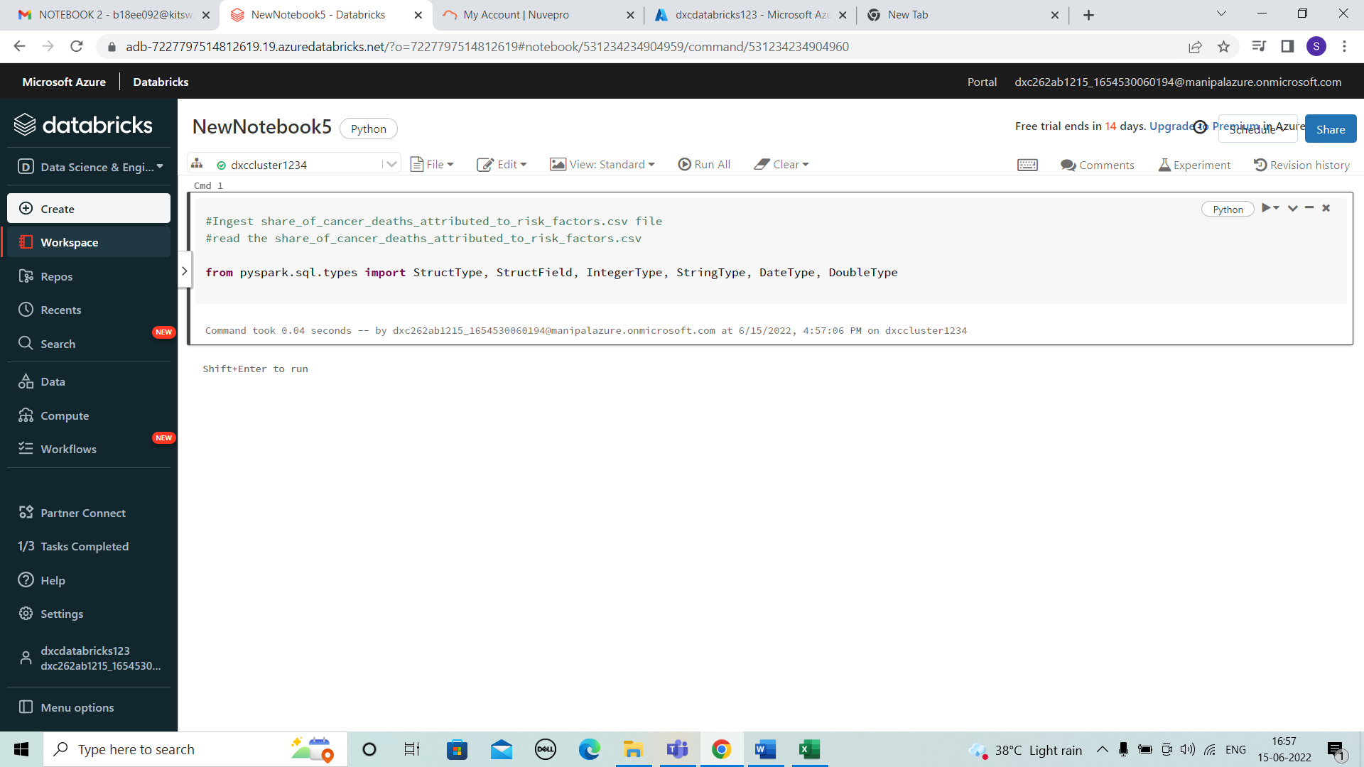

* Enter the details of all the columns that are considered in the file. And the type of data used.

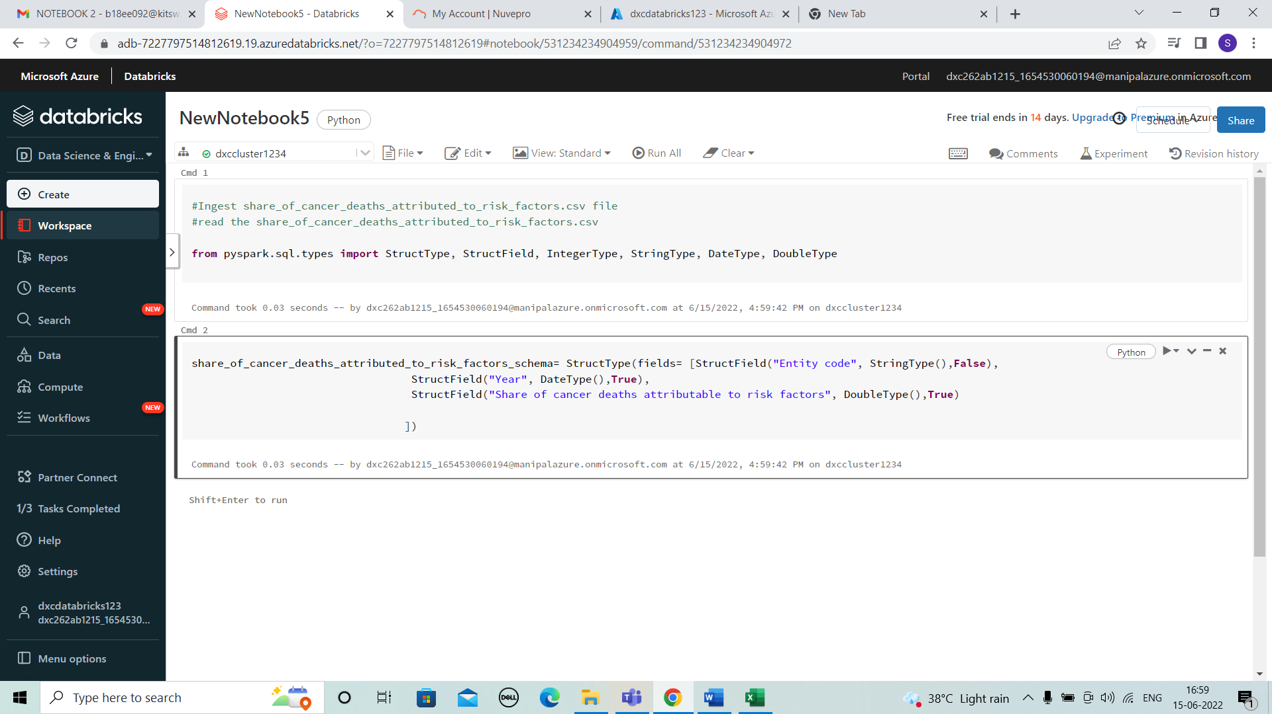

* Here the below code shows the data used.

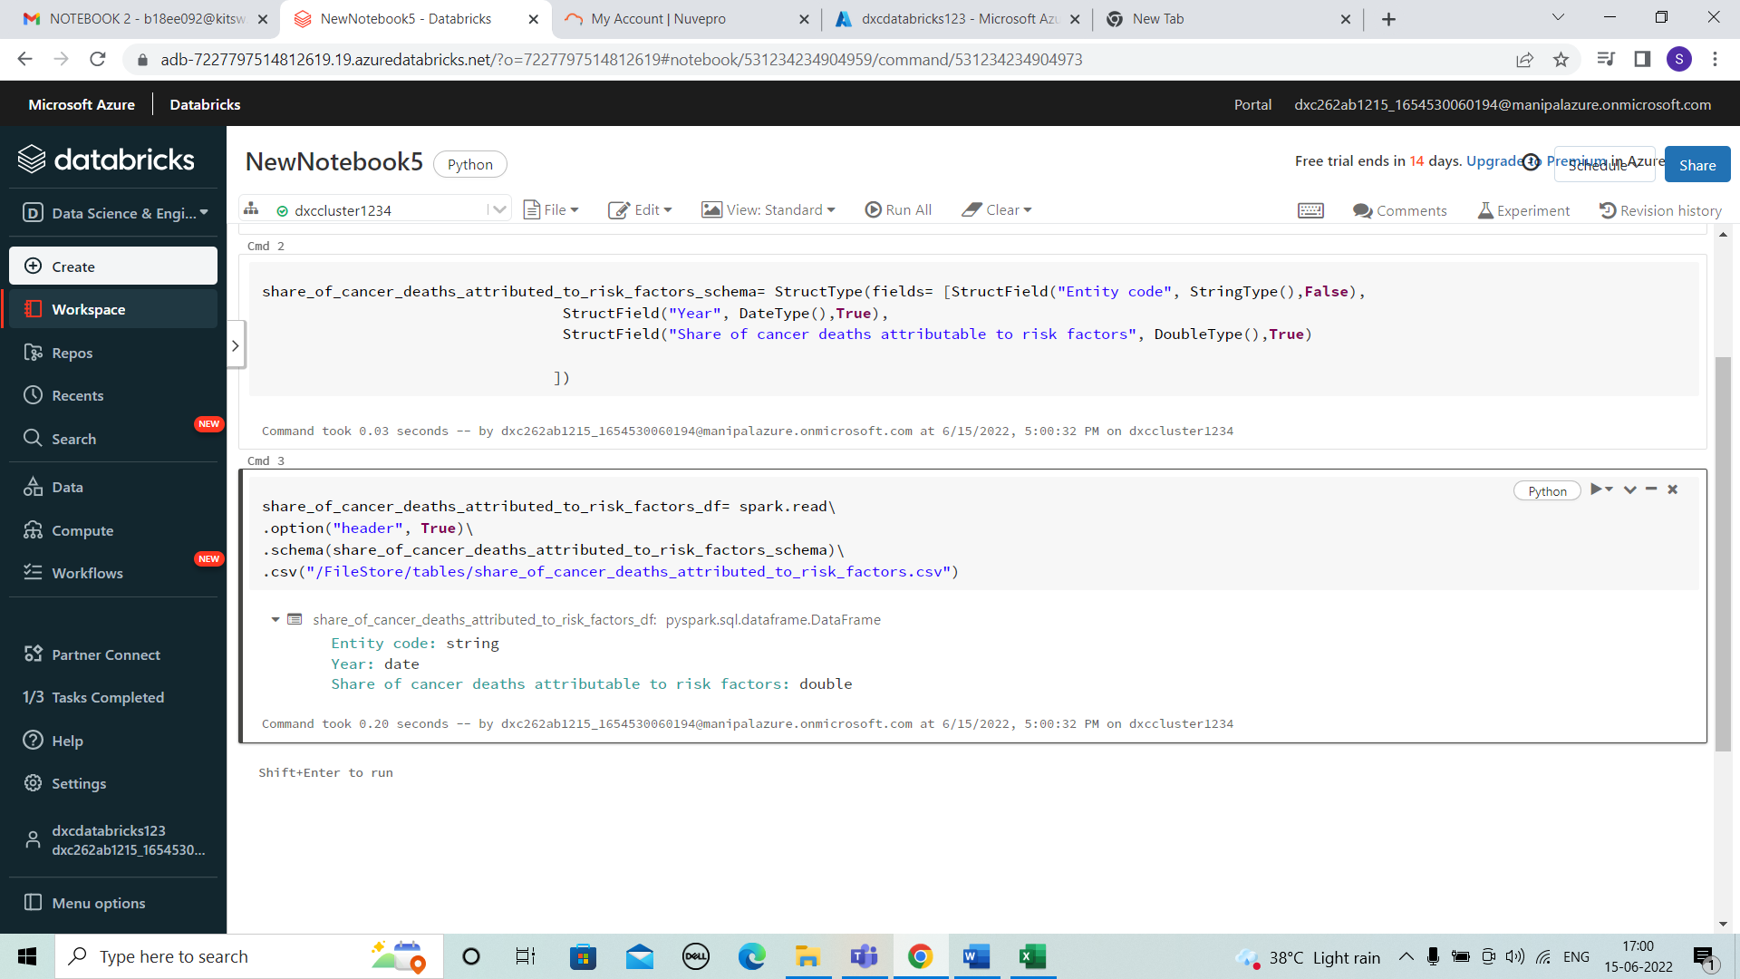

* We add the ingestion date for the data.

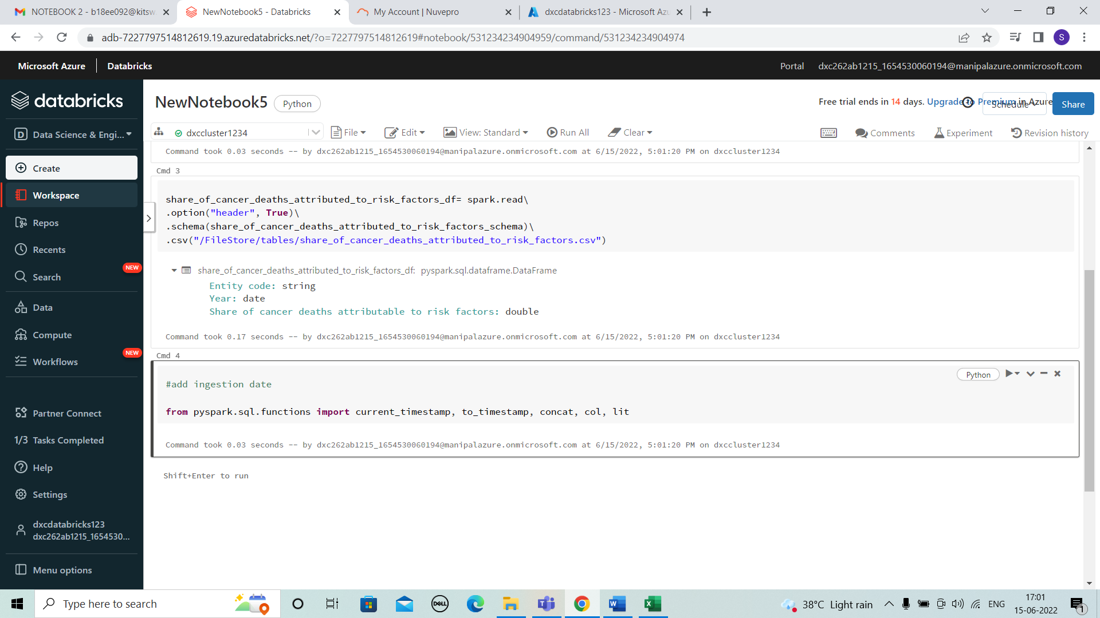

* Here we can view the ingestion date id added and type used is displayed.

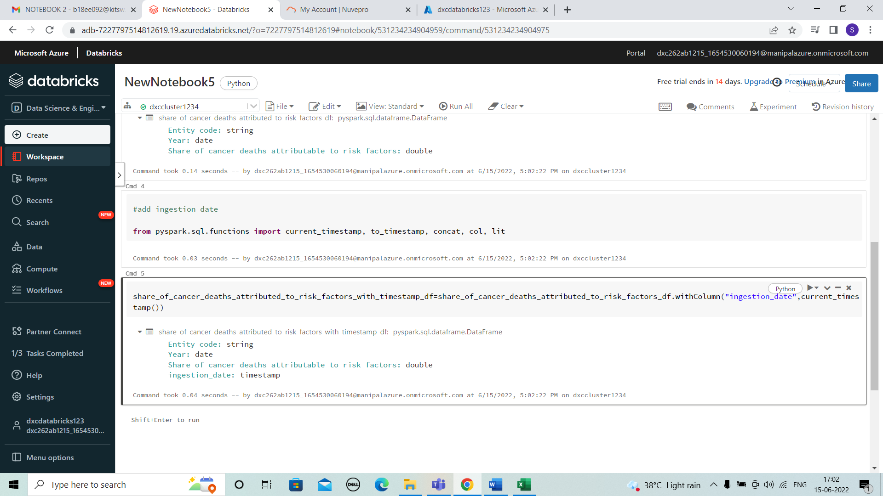

* Here, We need to select the column names which should be renamed and enter the names to be replaced.

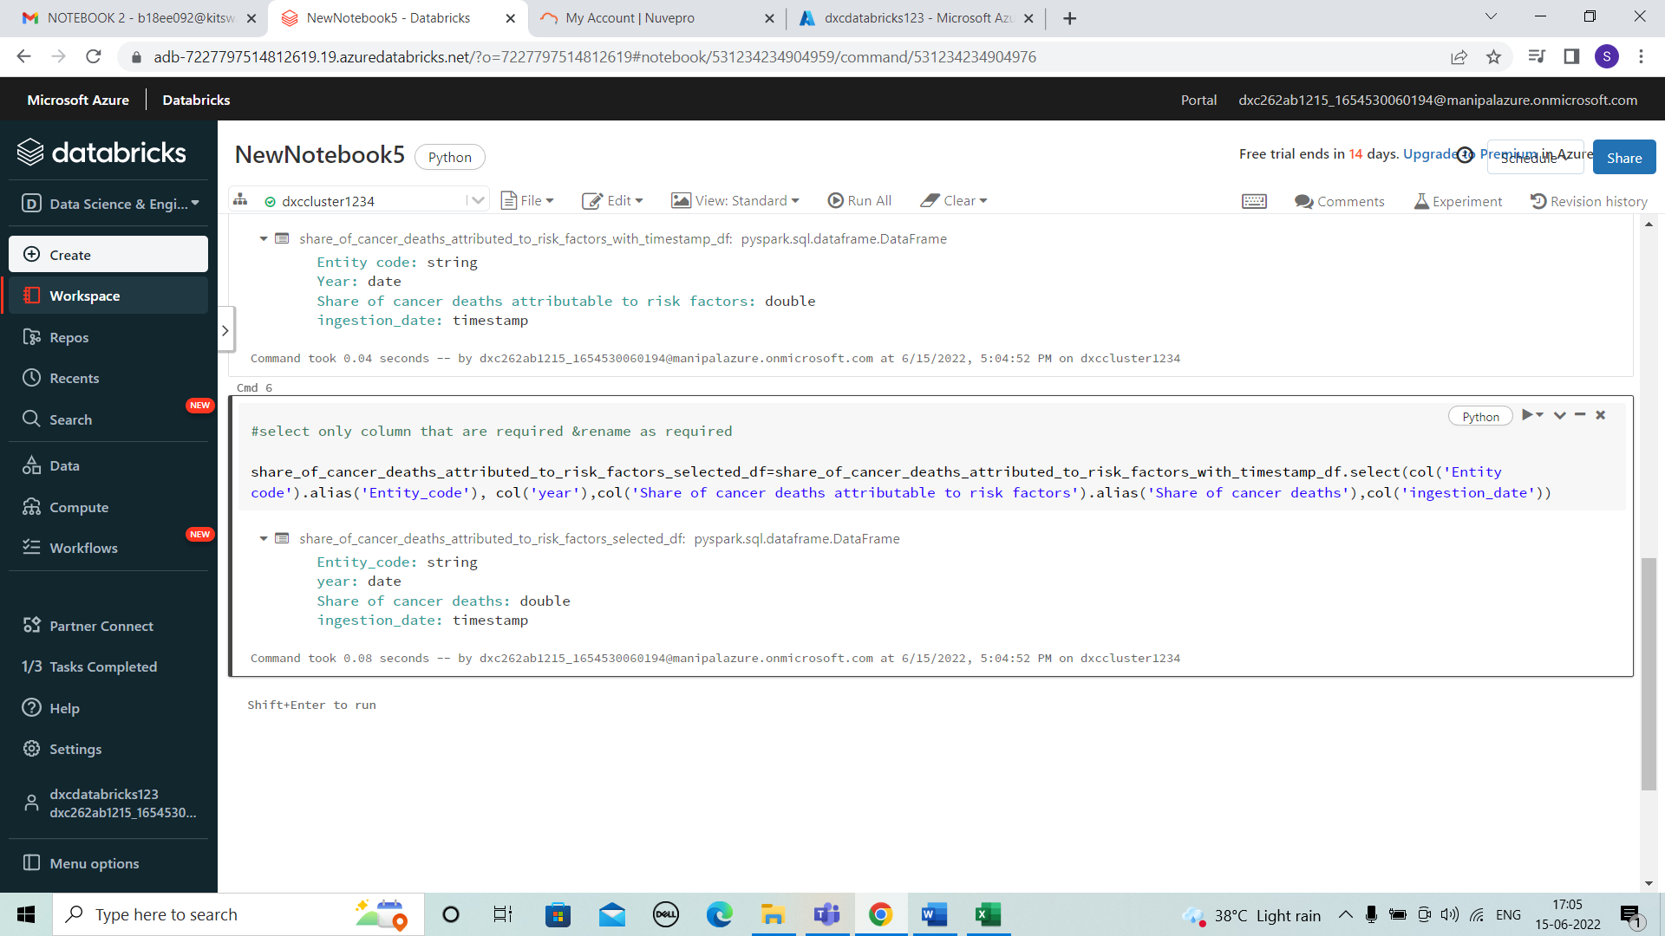

* Next the output to processed container in parquet format to view the spark job.

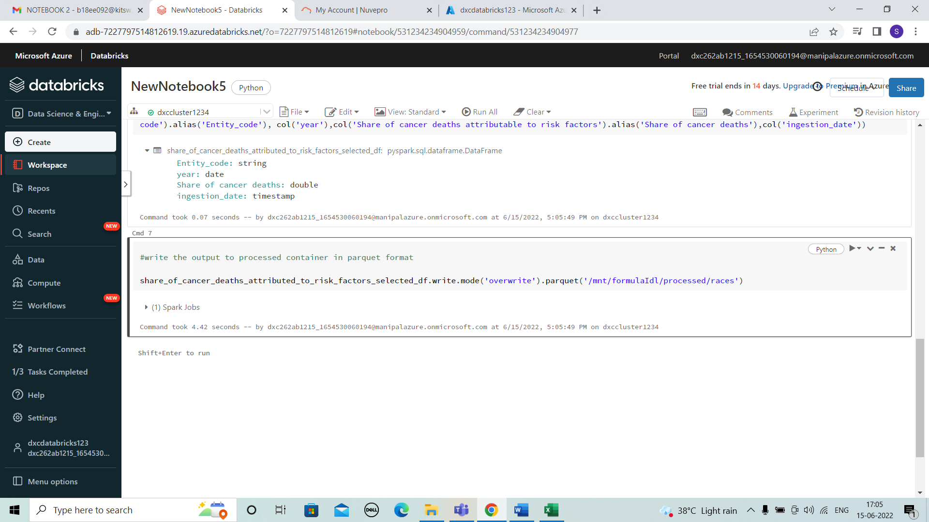

* Using view option we can see the spark job.

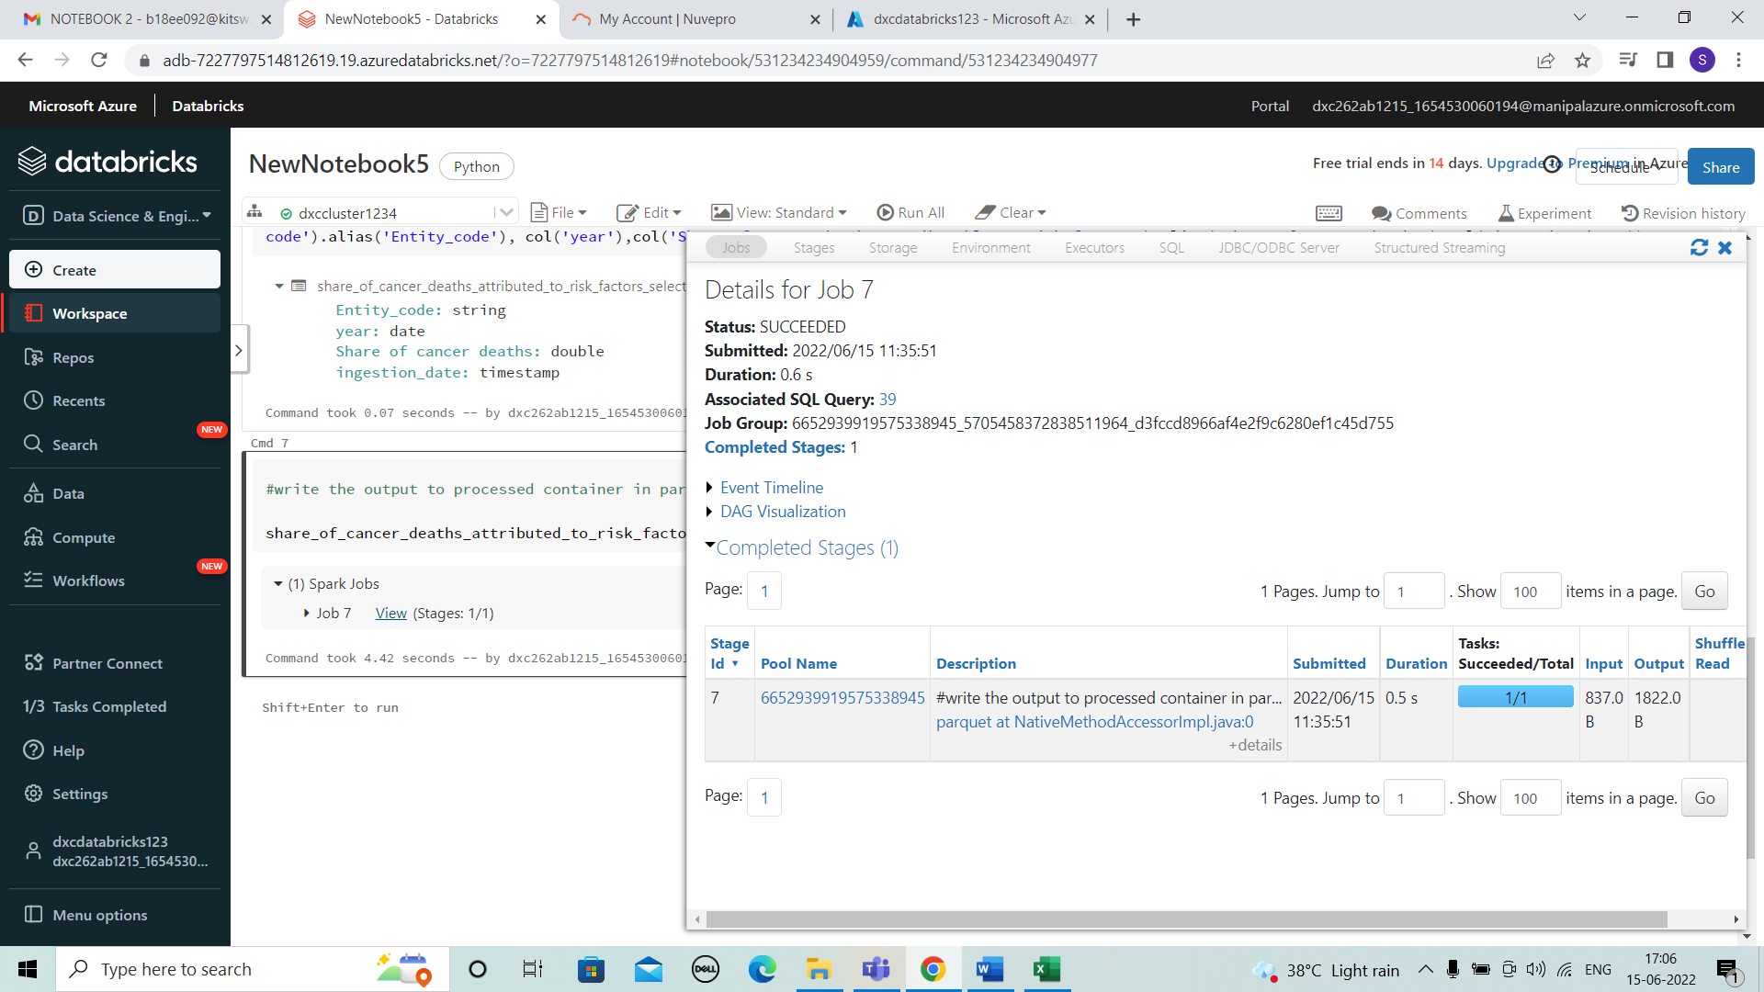

* Enter the below code to view the final table or the data modifies in the notebook.

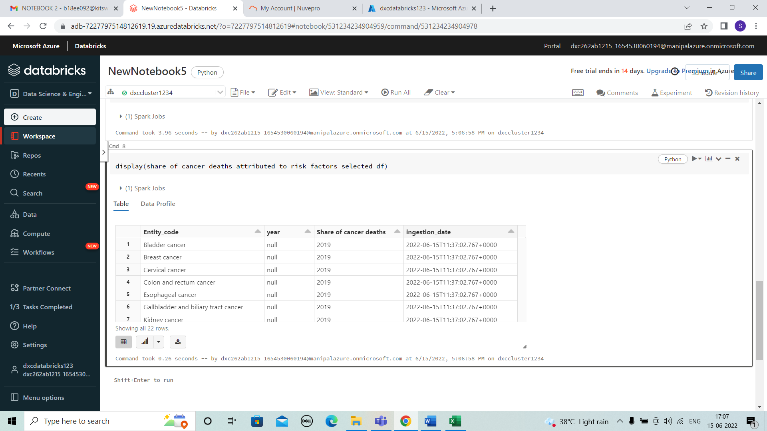

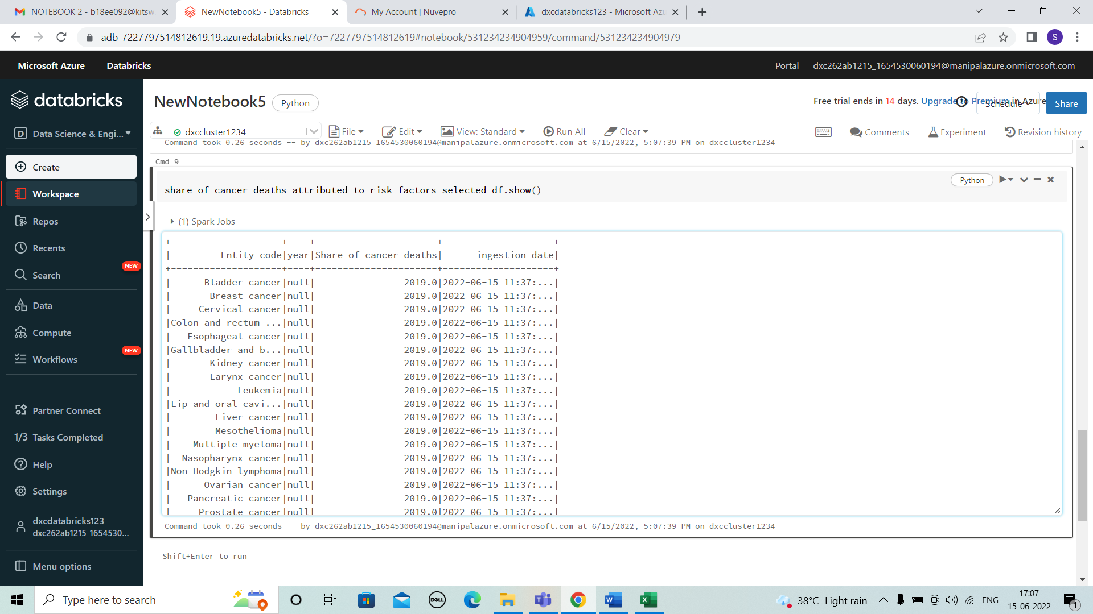

6.Using archive6.zip file - please ingest data into databricks DBFS path & query the data redesign columns accordingly using dafarame commands - display with notebooks accordingly

SOLUTION

* Open notebook and enter the code below to ingest and read file.

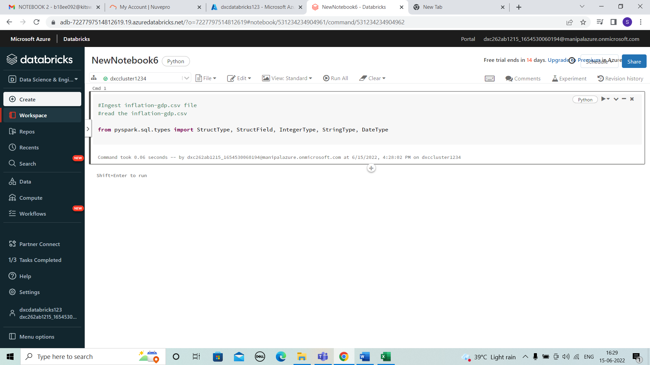

* Enter the details of all the columns that are considered in the file. And the type of data used.

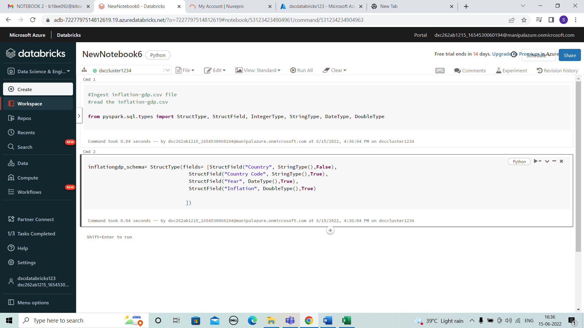

* Here the below code shows the data used.

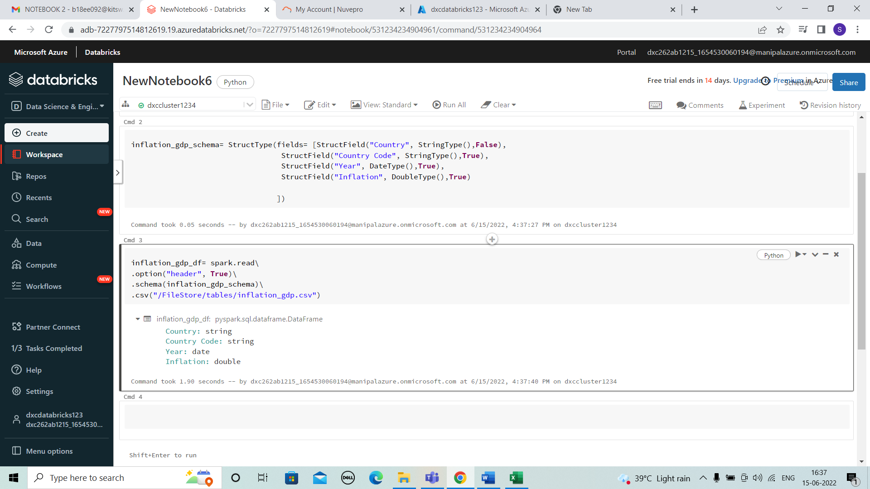

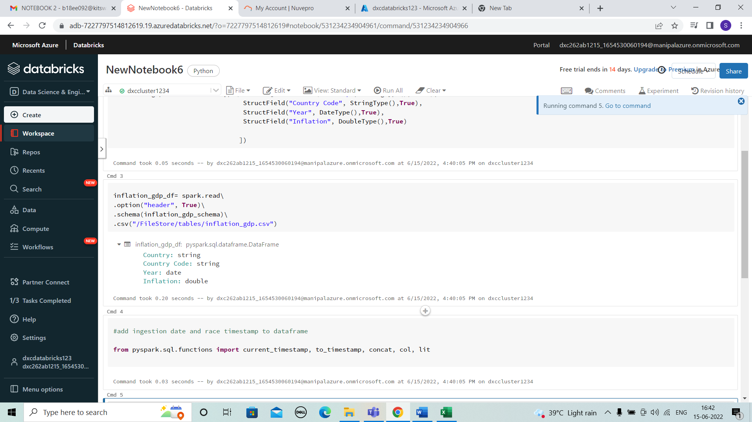

* We add the ingestion date for the data.

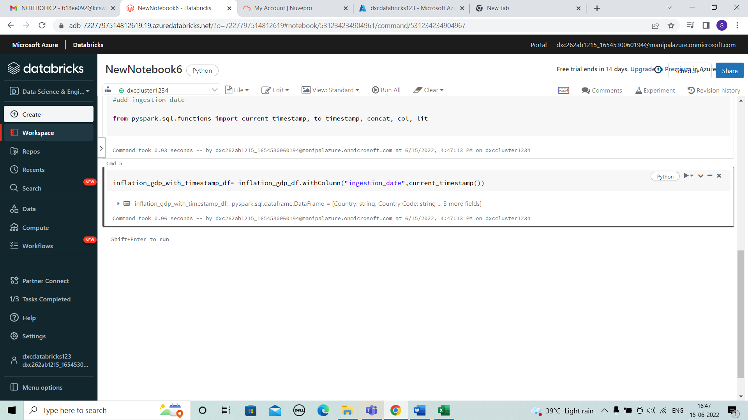

* Here, We need to select the column names which should be renamed and enter the names to be replaced.

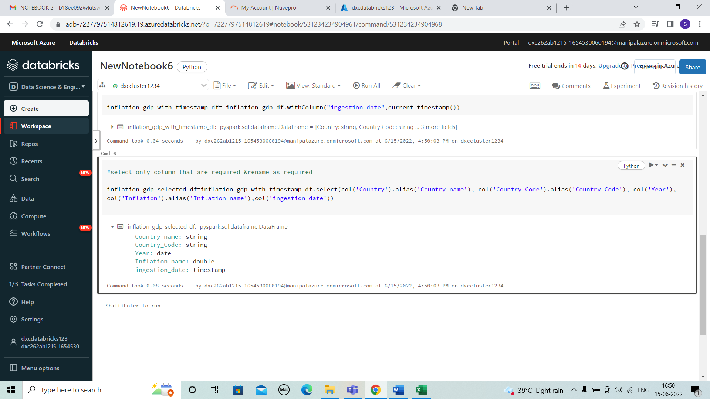

* Next the output to processed container in parquet format

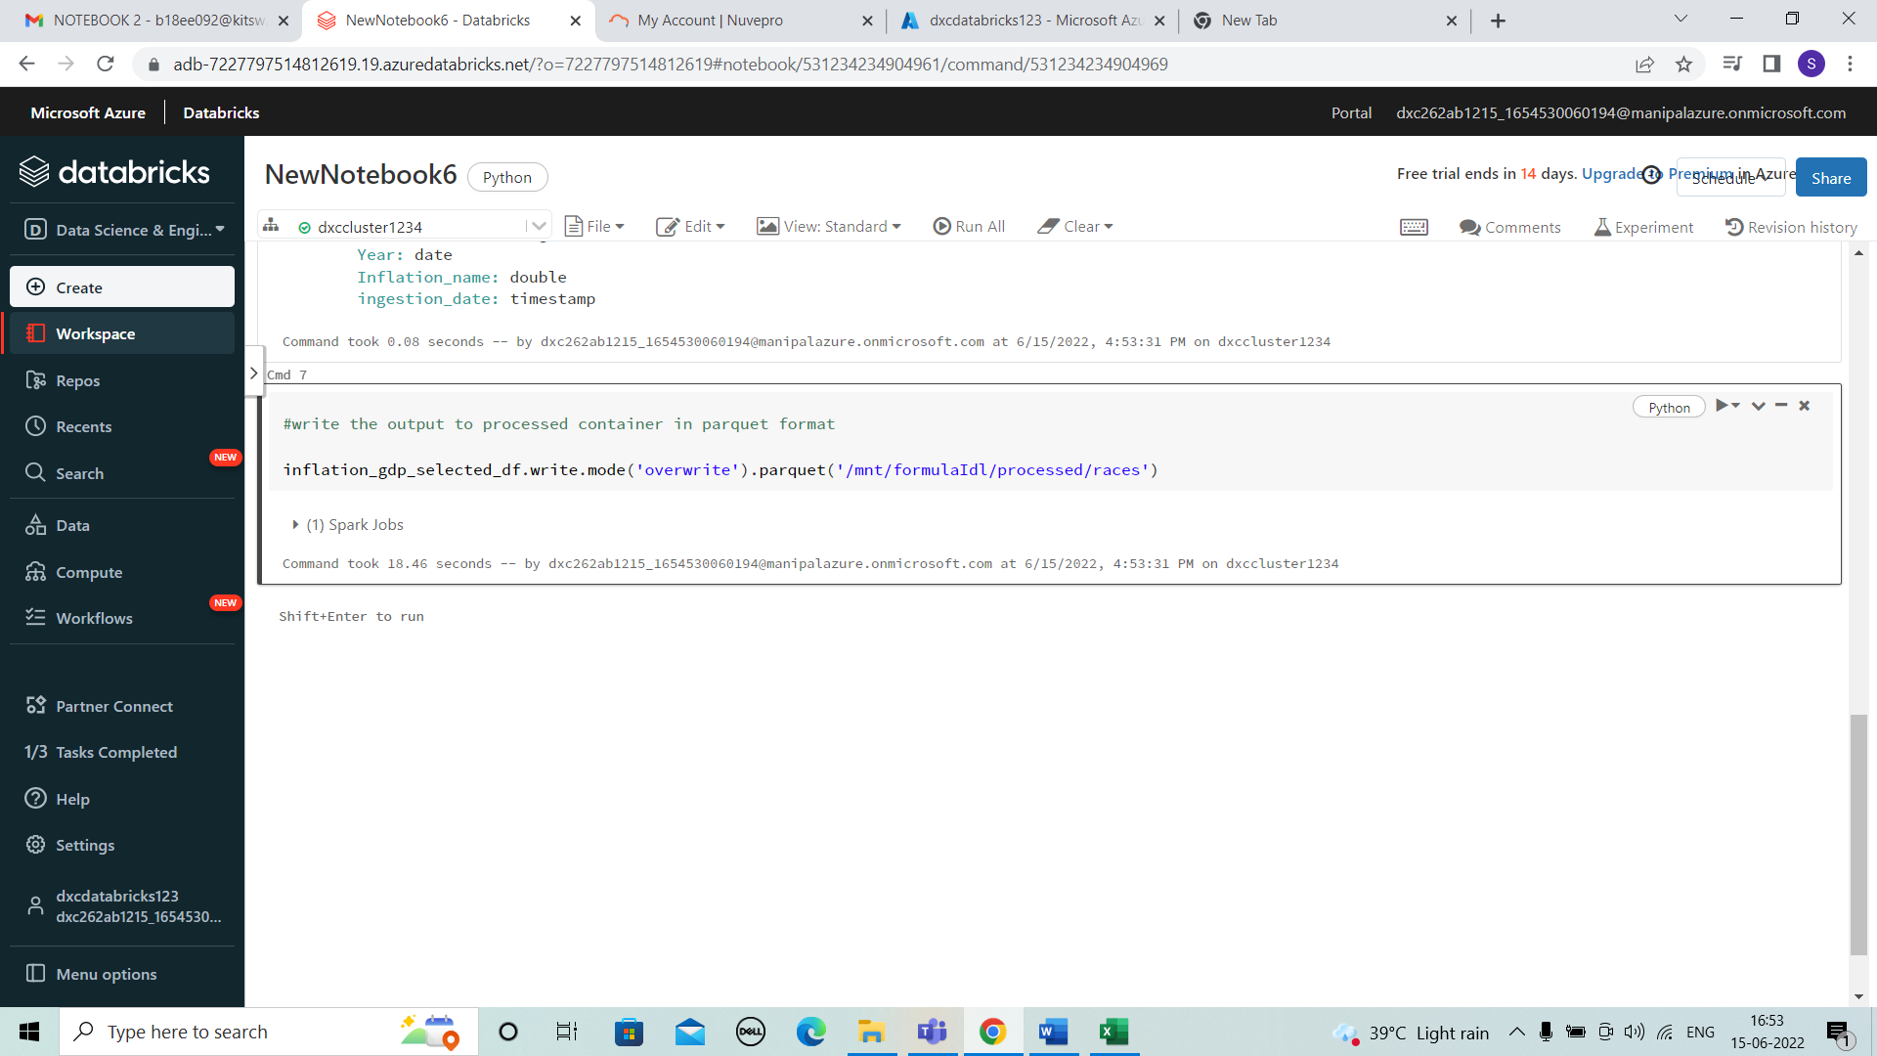

* After the output to processed container in parquet format. And view the spark job.

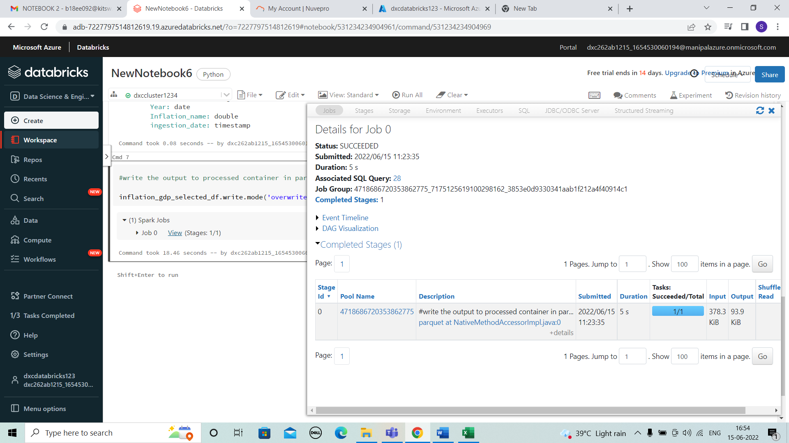

* Enter the below code to view the final table or the data modifies in the notebook.

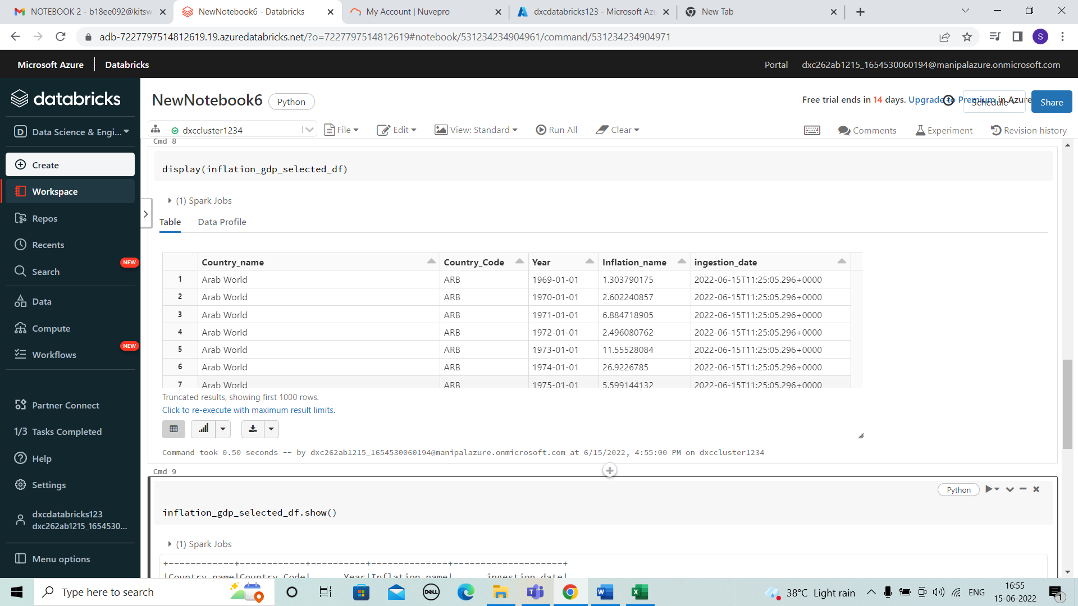

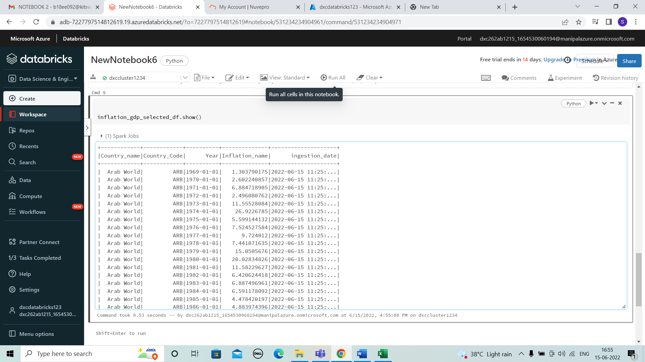

RESULTS:

I HAVE SUCCESSFULLY ANSWERED ALL THE QUESTIONS AS PER ASSIGNMENT REQUIREMENT.

CONCLUSIONS:

All the questions have been solved successfully with all the concepts that have been covered in the training session. It’s really a great experience of learning while solving the cases. This assignment gave me immense confidence regarding my ability to upskill in new technologies.